**Project Documentation**

Name : Hitesh Jethava

Enrollment No : 92100133010

Subject : .NET

**Hotel Management System**

**Introduction :**

1. Purpose :

The Hotel Management System purpose is to solve people hotel booking problems and very useful in tourist business. It gives availability of rooms and price also. It makes all process easy.

1. Document Conventions :

HTML

CSS

JAVASCRIPT

VISUAL STUDIO 2022

MICROSOFT SQL SERVER

1. Functions :

* Admin can add new customer, new user, new staff, new room and etc.
* Admin can edit also all details.
* Admin can delete also details.
* They can provide rooms availability and price.
* Manage staff
* User can Book the rooms and see availability status.
* Admin also can book the rooms.

1. Operating Environment :

Operating System: Windows operating System that supports browsing.

Database: Microsoft SQL server

Front-end: HTML, CSS

Programming Language: .net, c#

Framework: Bootstrap

1. User Interface :

All Page Design :

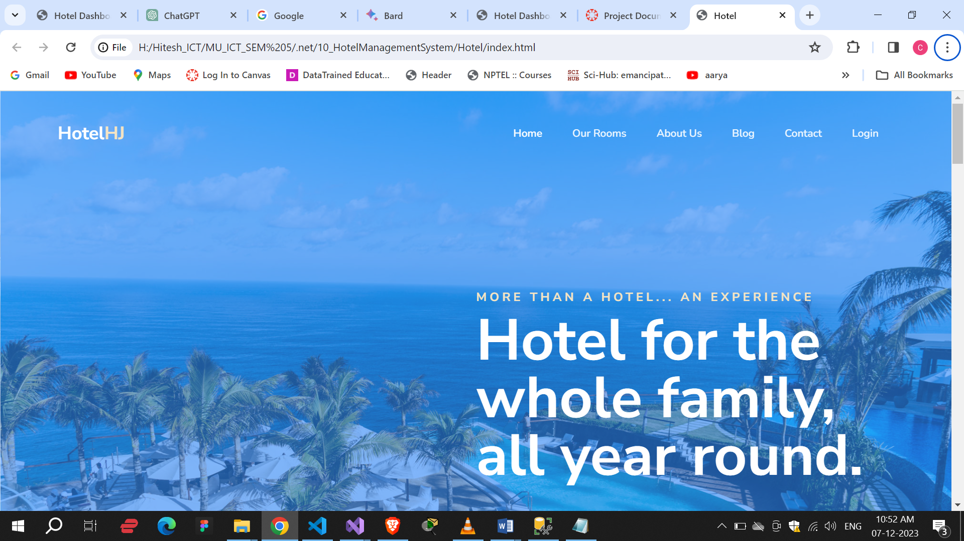

Register :

Here User and Admin can register.

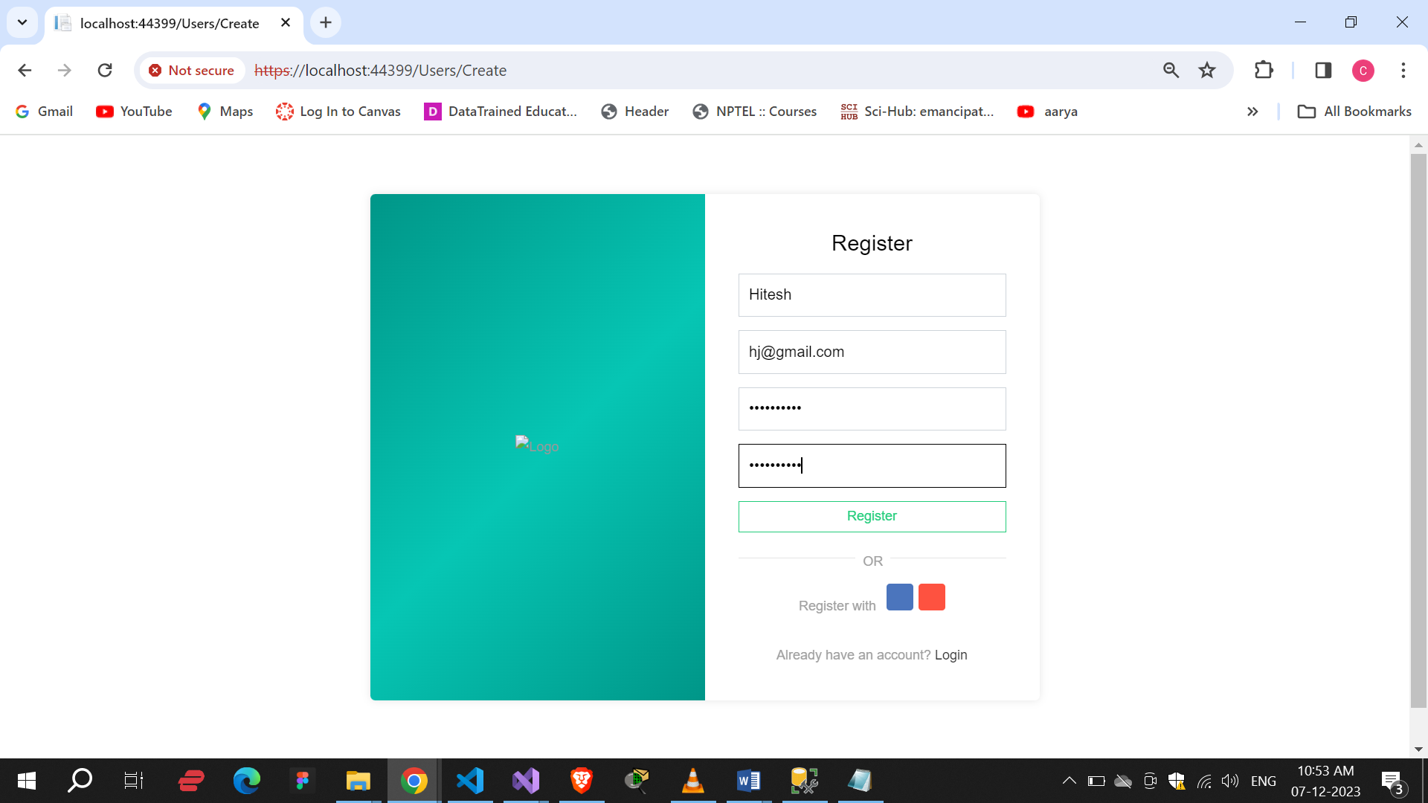

Login :

Here User and admin can login.

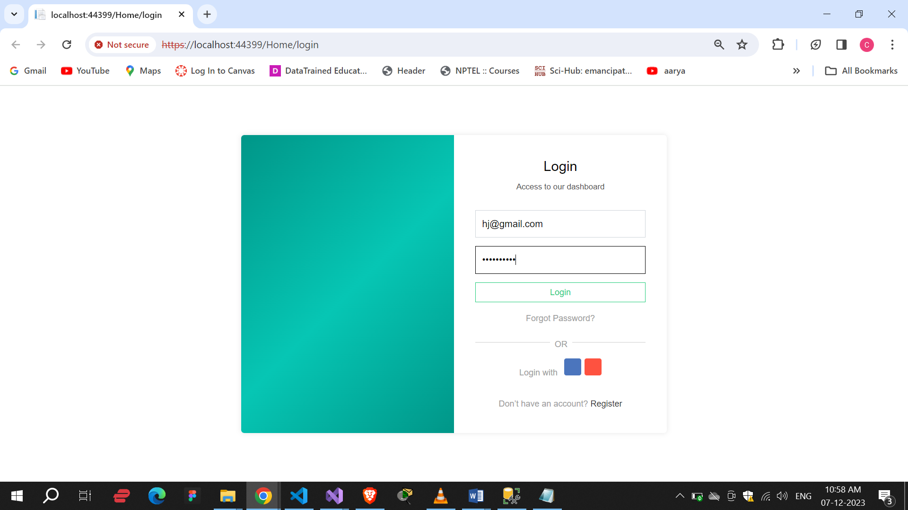

User Details :

Here we can see the all details of users and admin who registered.

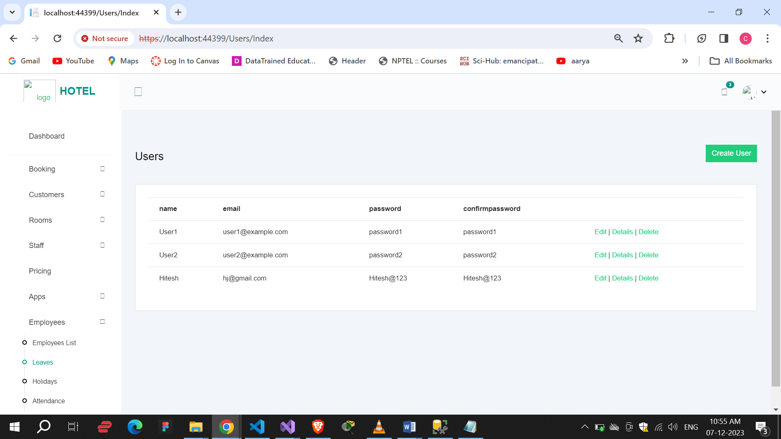

User Edit :

Here we can edit the details of user and admins’s login.

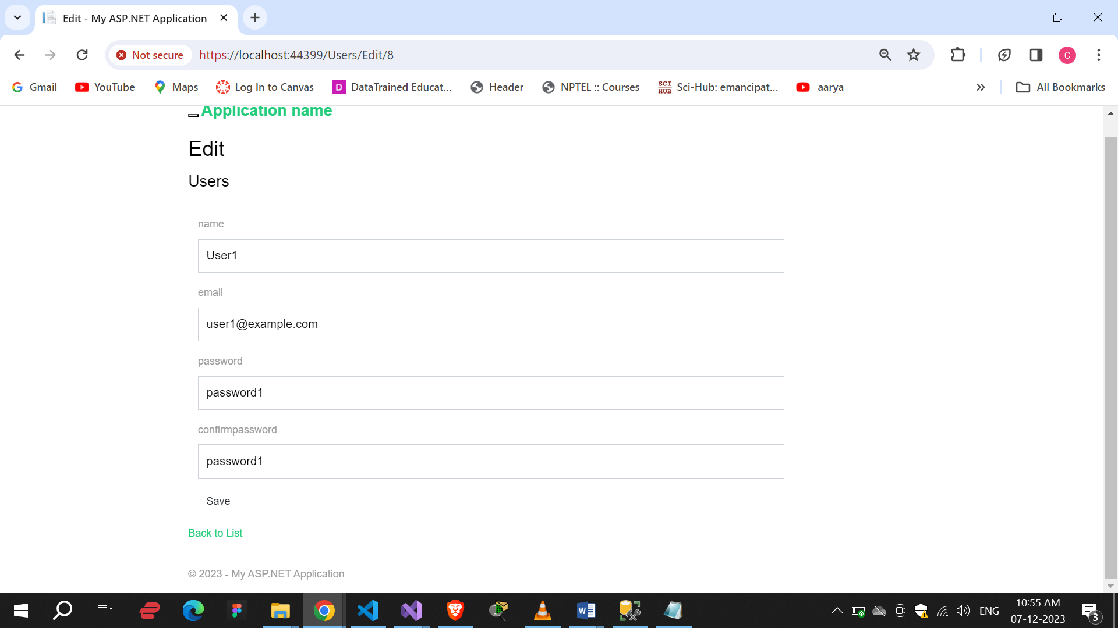

User Details :

Here we can see the all details of user and admin like name, email id and password.

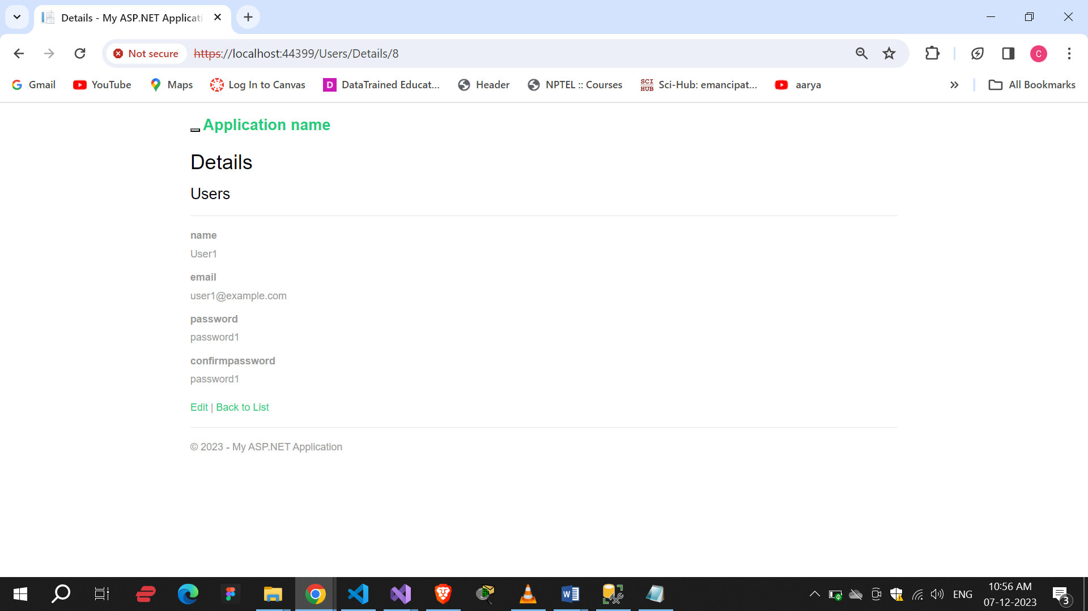

Delete user :

By delete button we can delete users and admins.

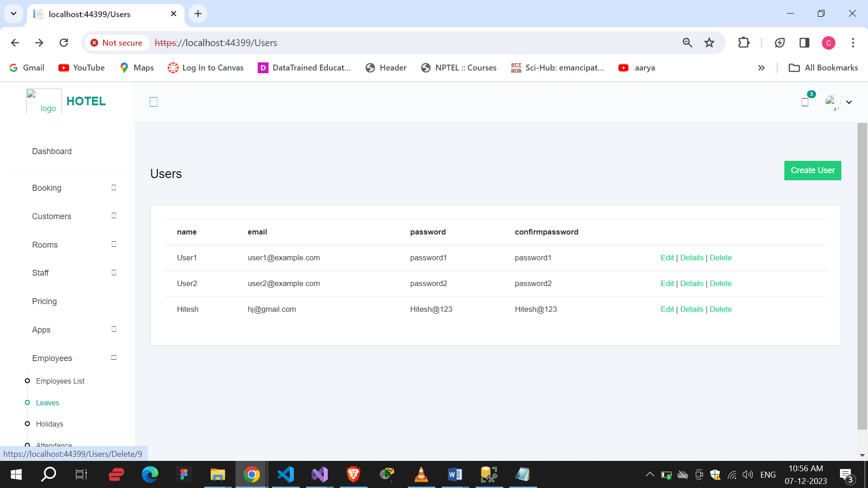

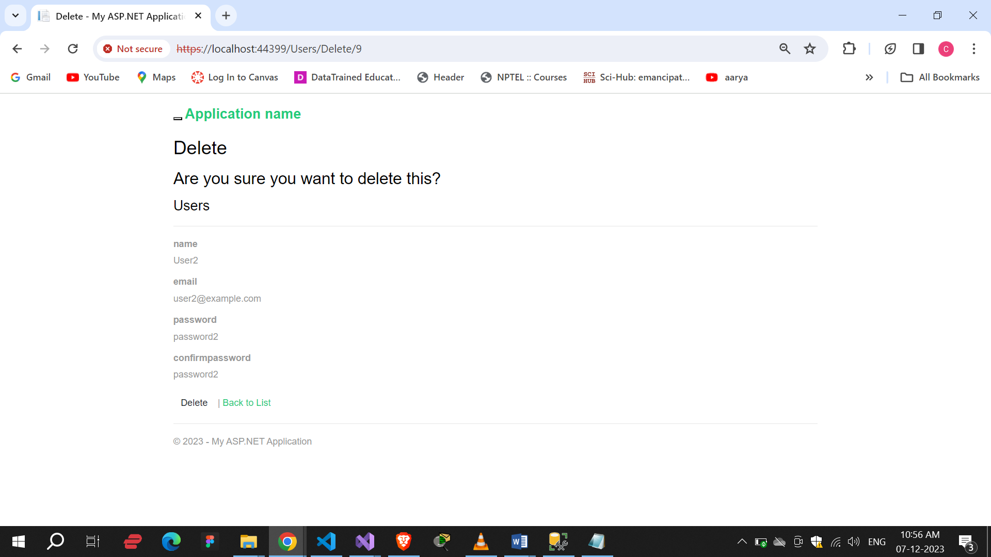

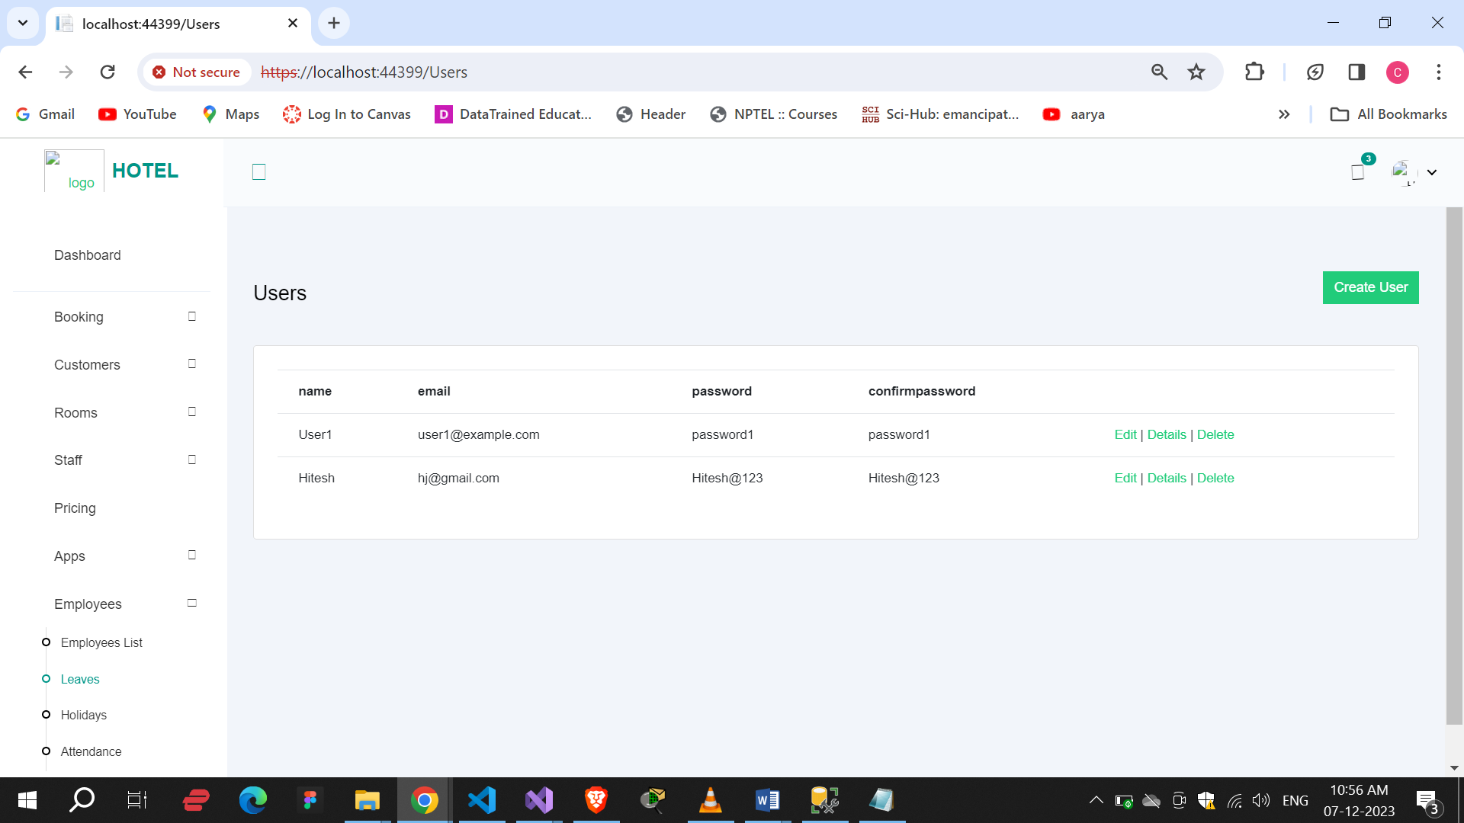

Bookings :

In this we can see the all details of booking.

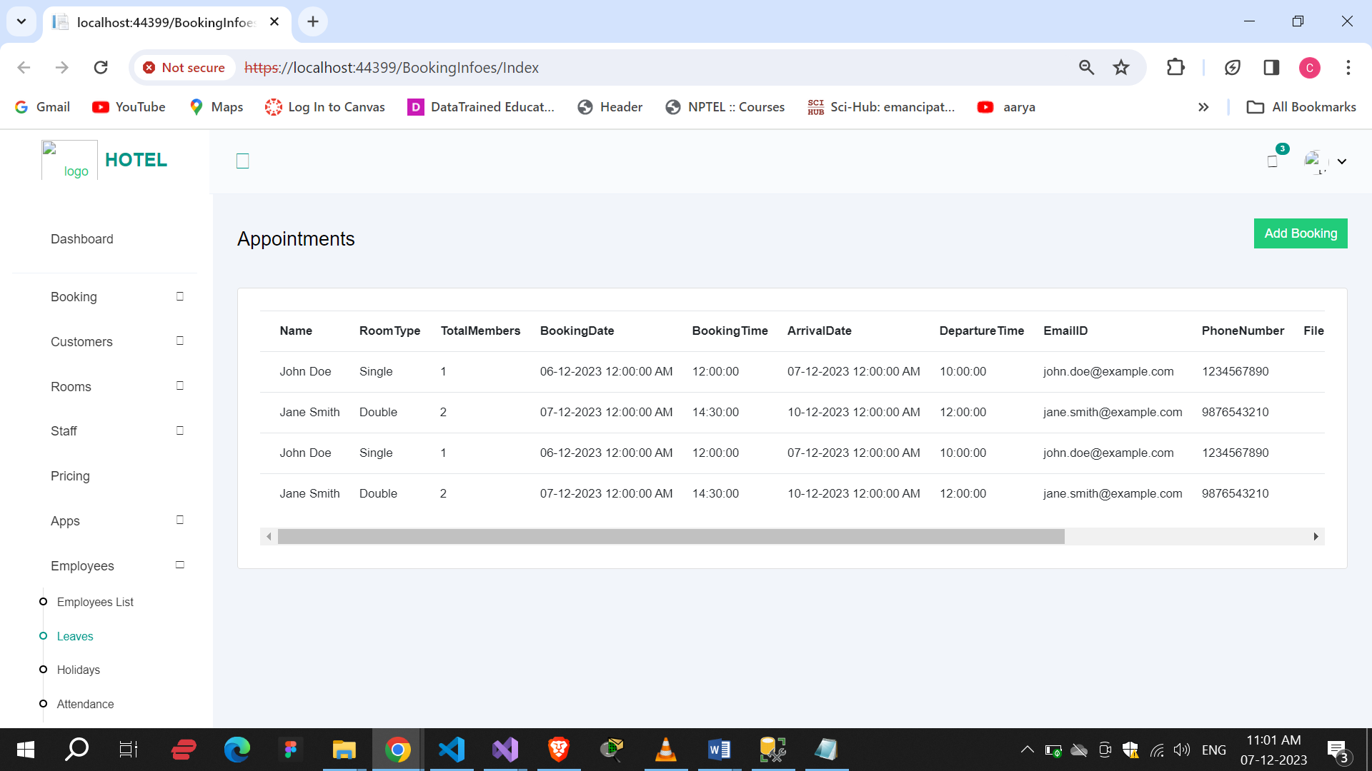

Here we can Add the new details of Bookings.

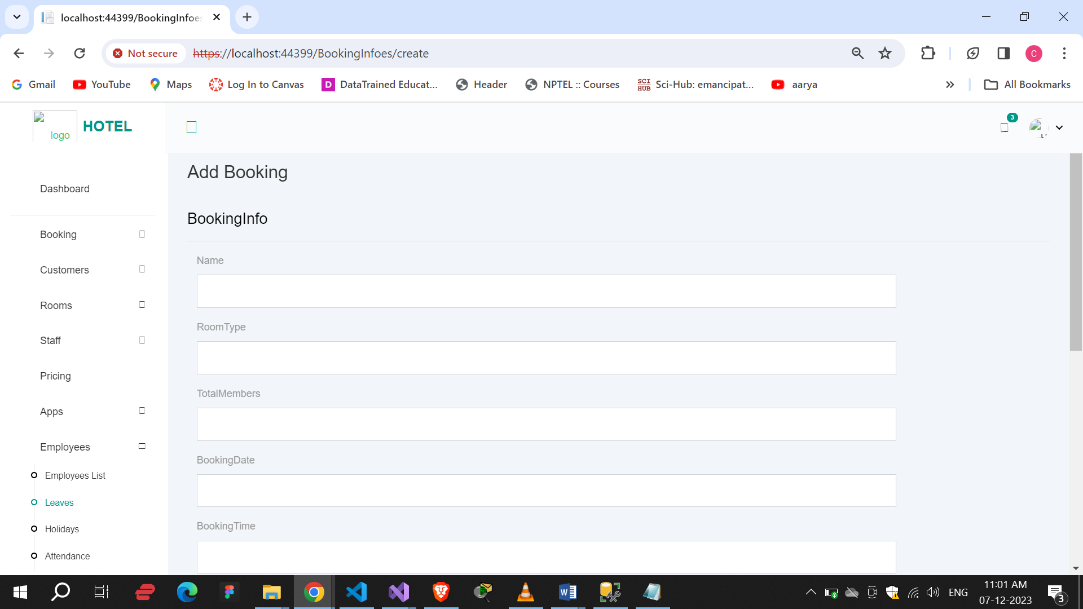

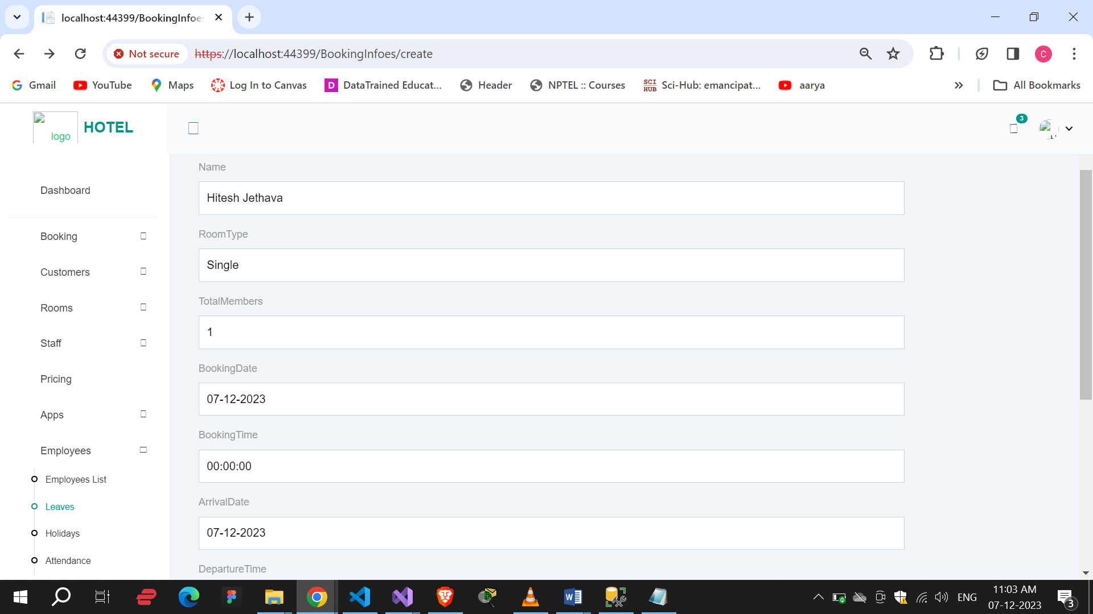

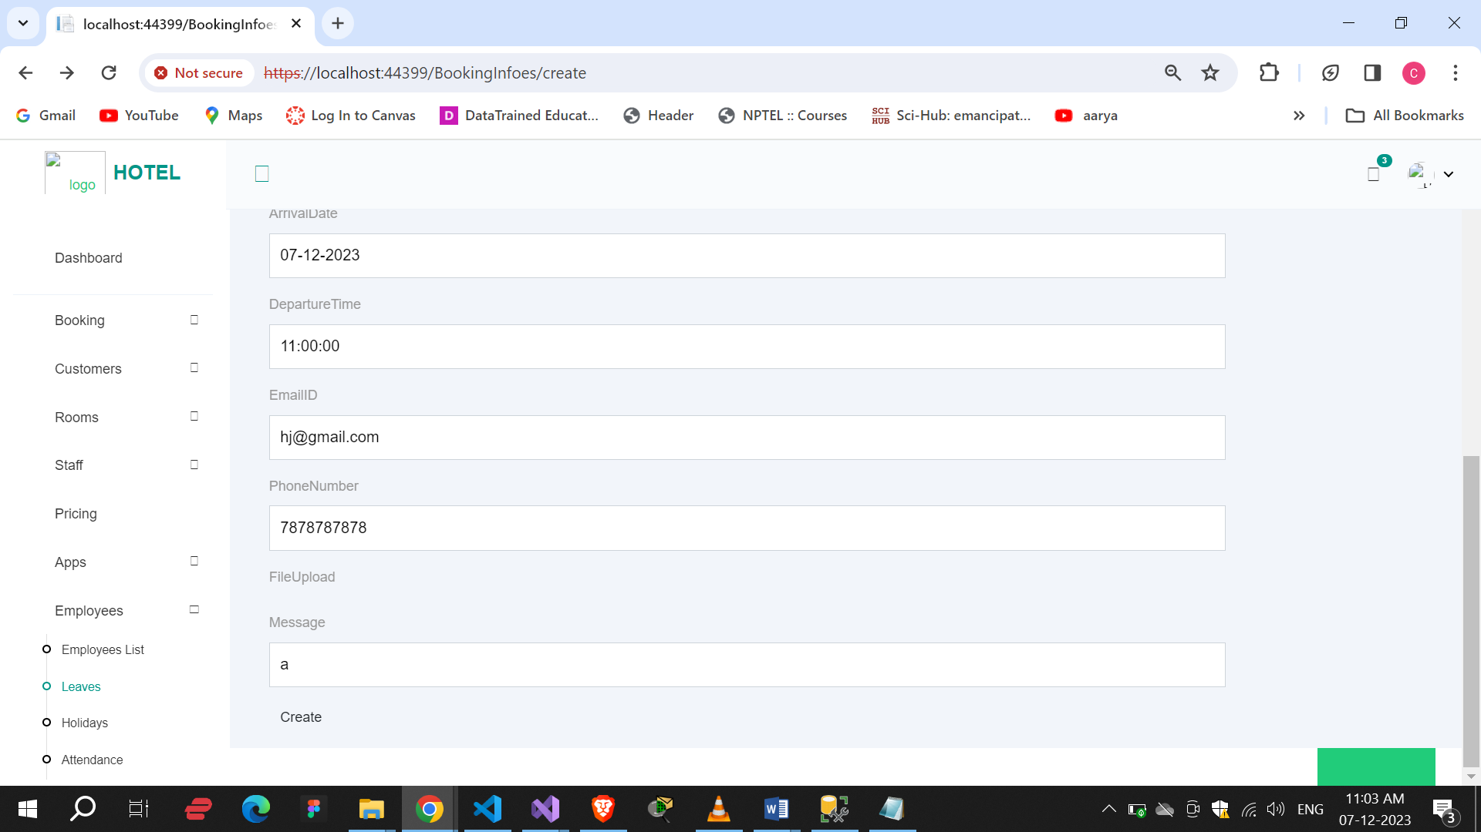

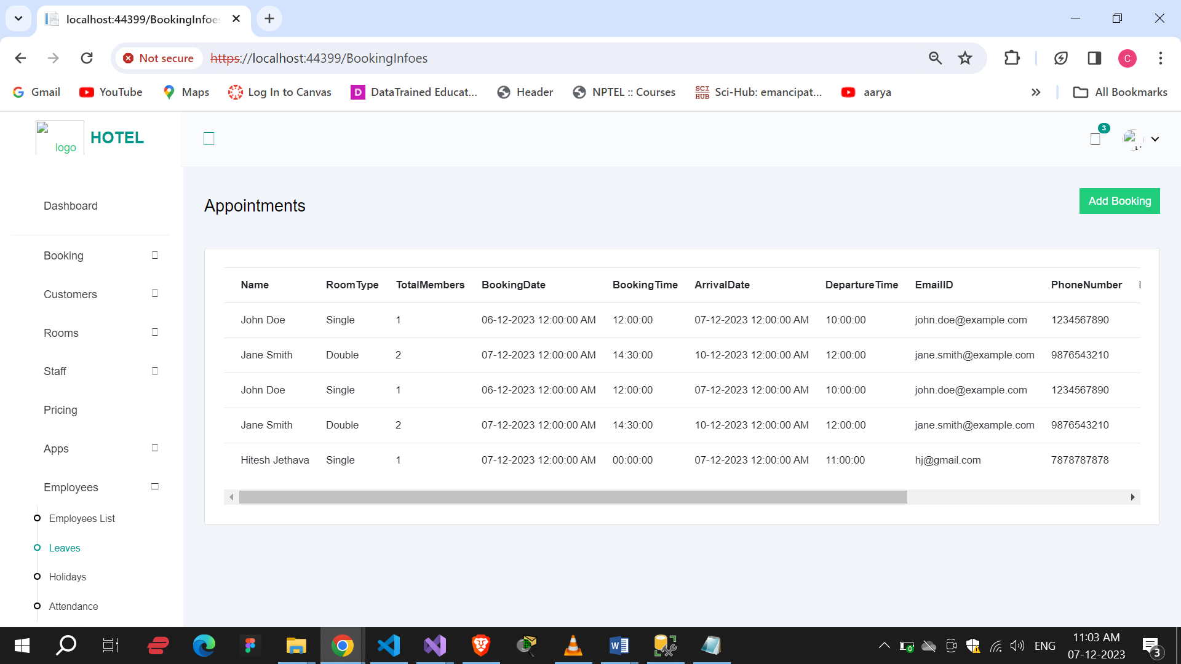

Edit :

Here we can edit the details of bookings.

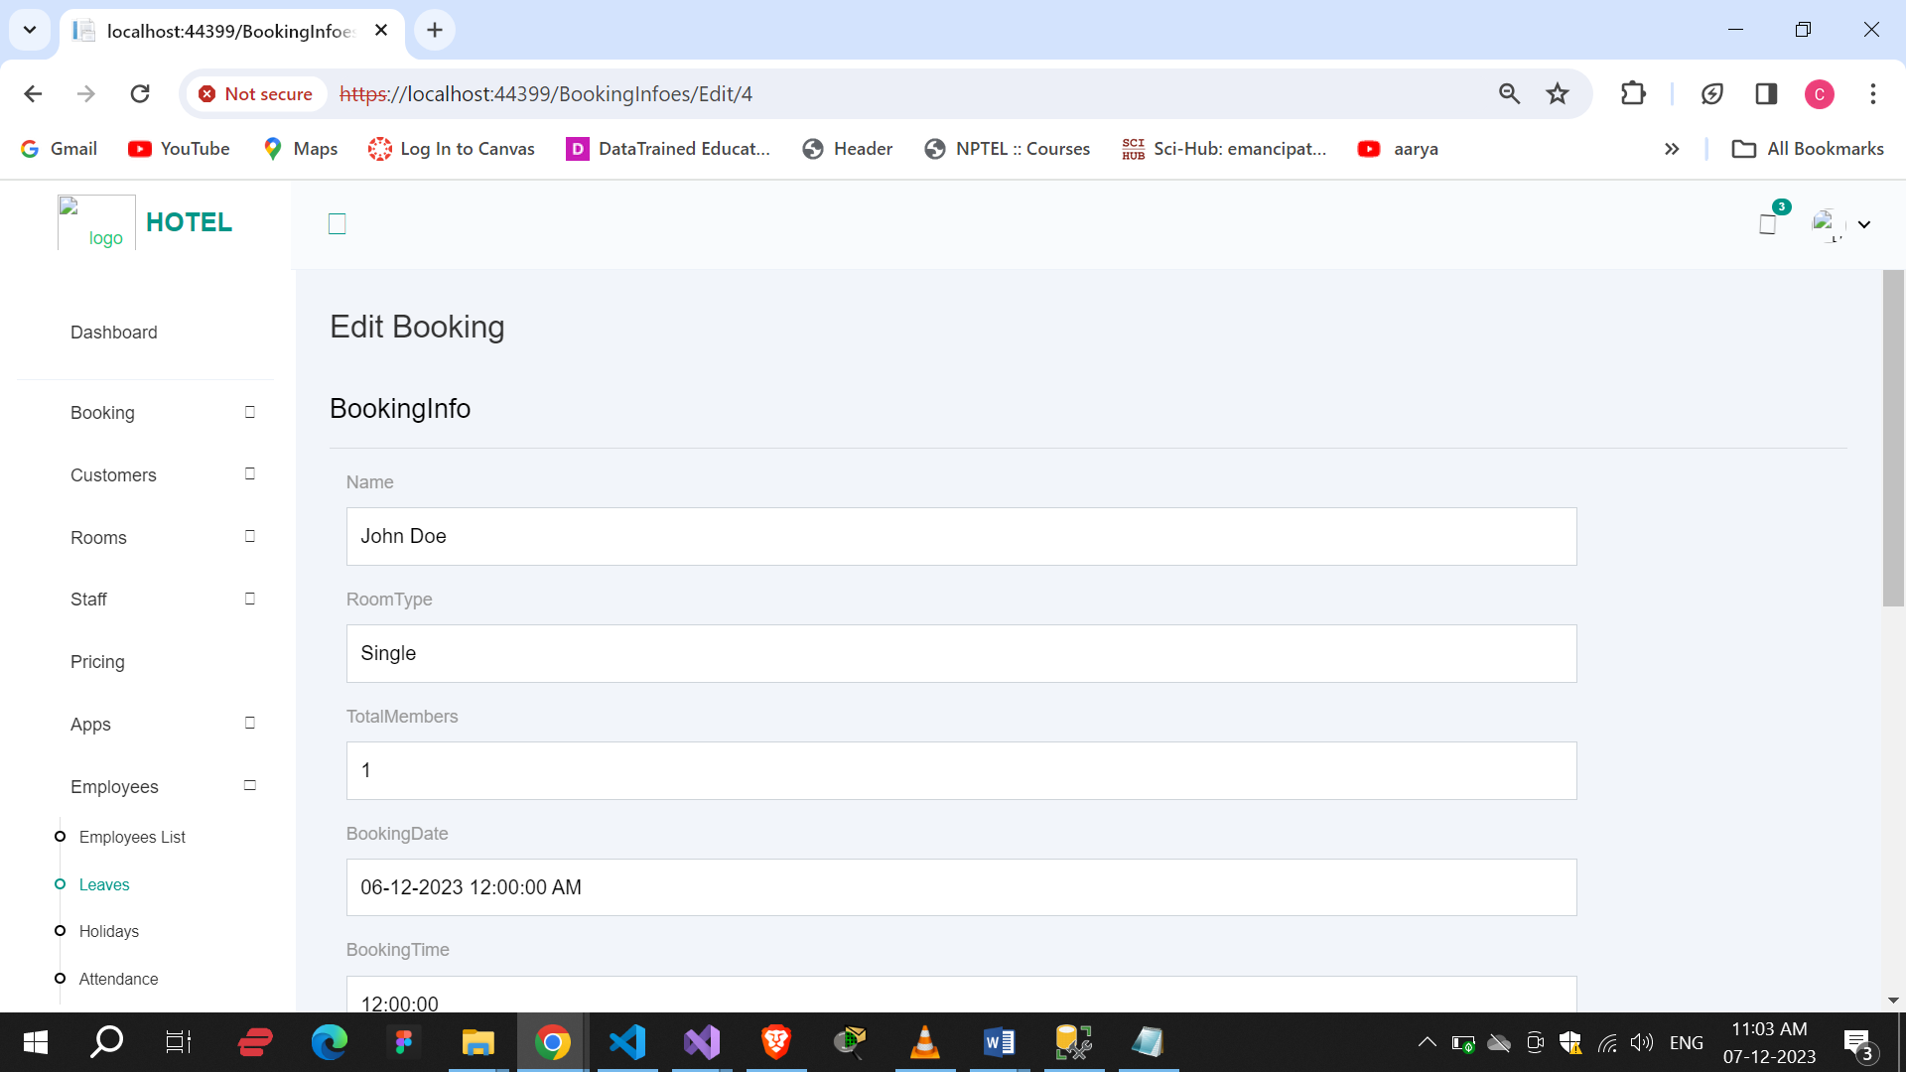

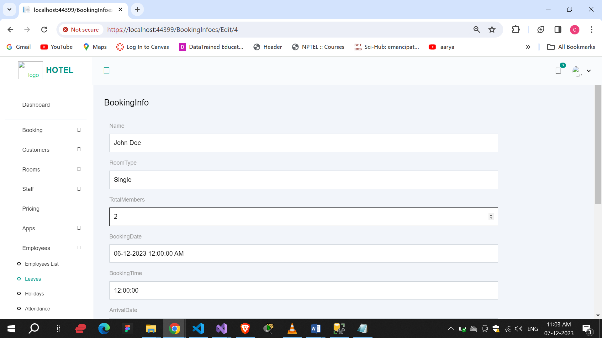

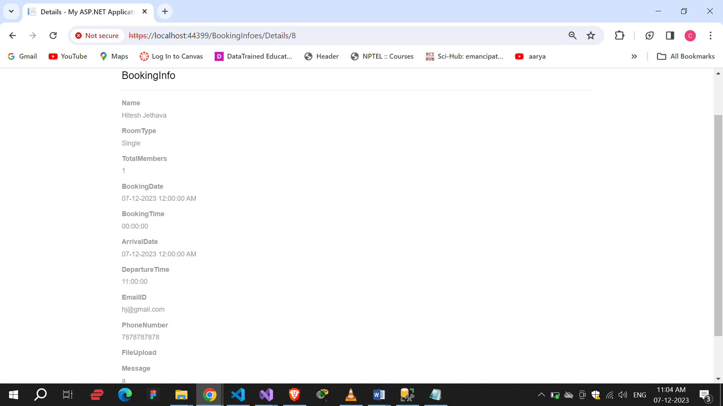

Here we can see all bookings.

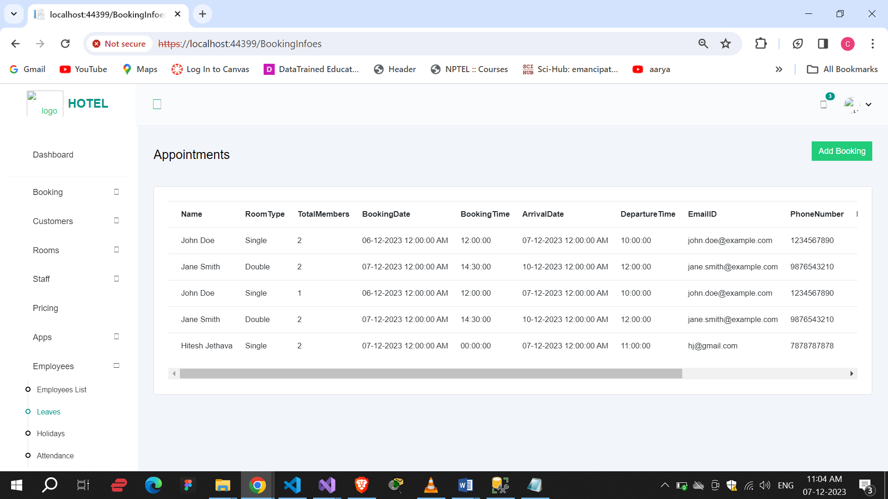

Here we can see perticular booking details.

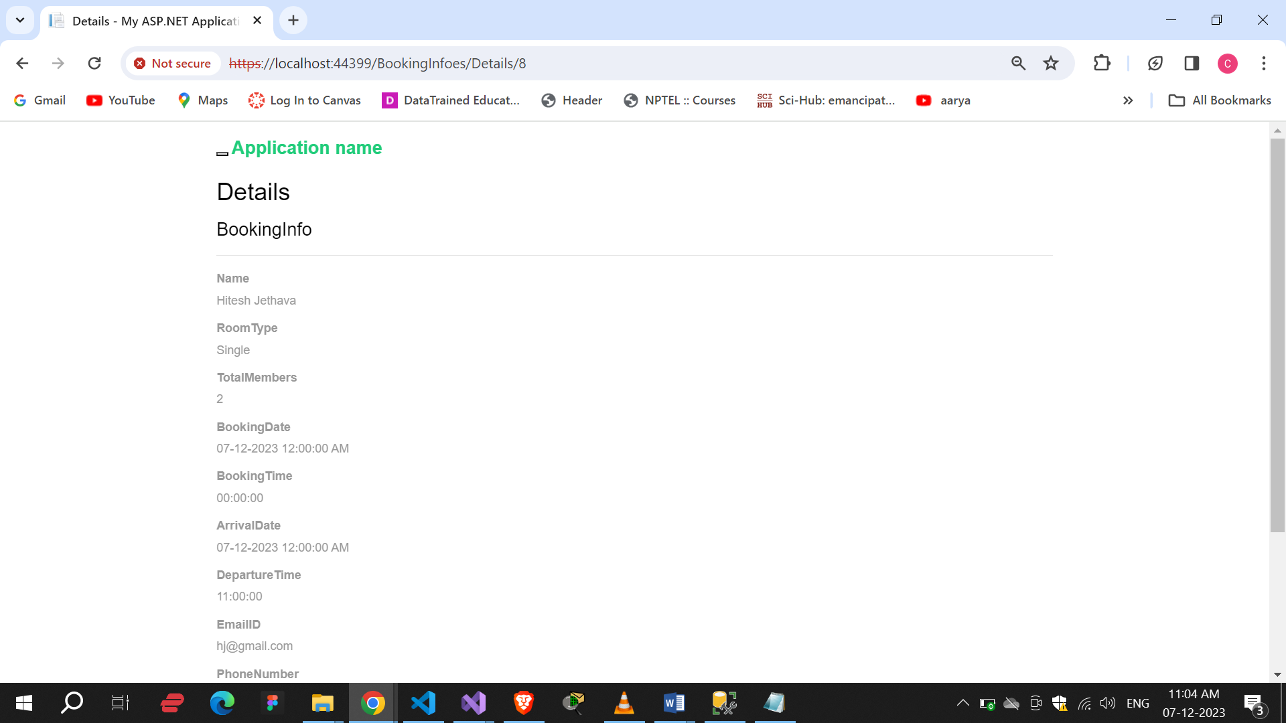

Delete :

By delete button we can delete bookings.

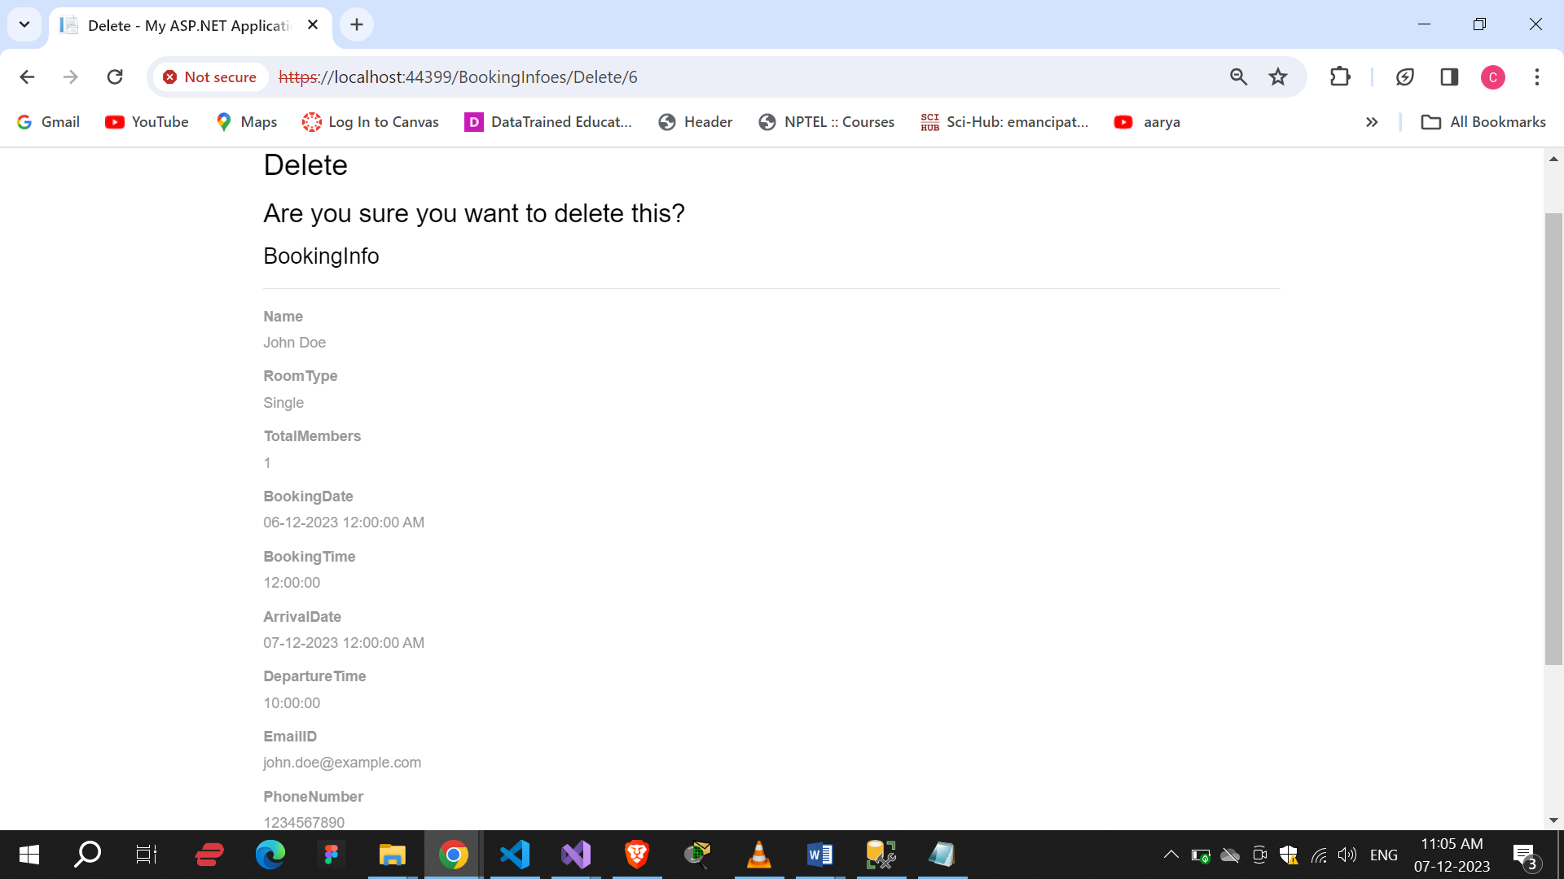

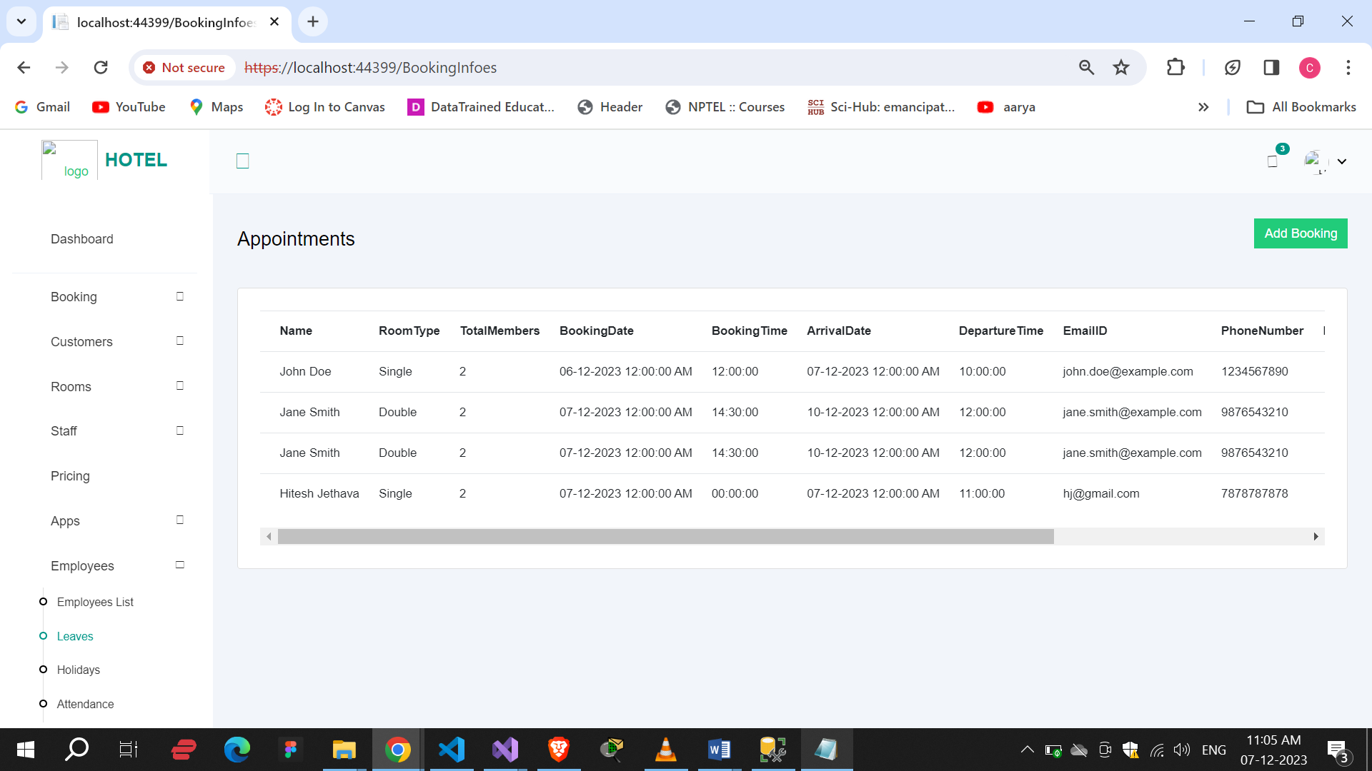

Customers :

Here we can see all the customers. By click on Add customer button we redirect to add customer page.

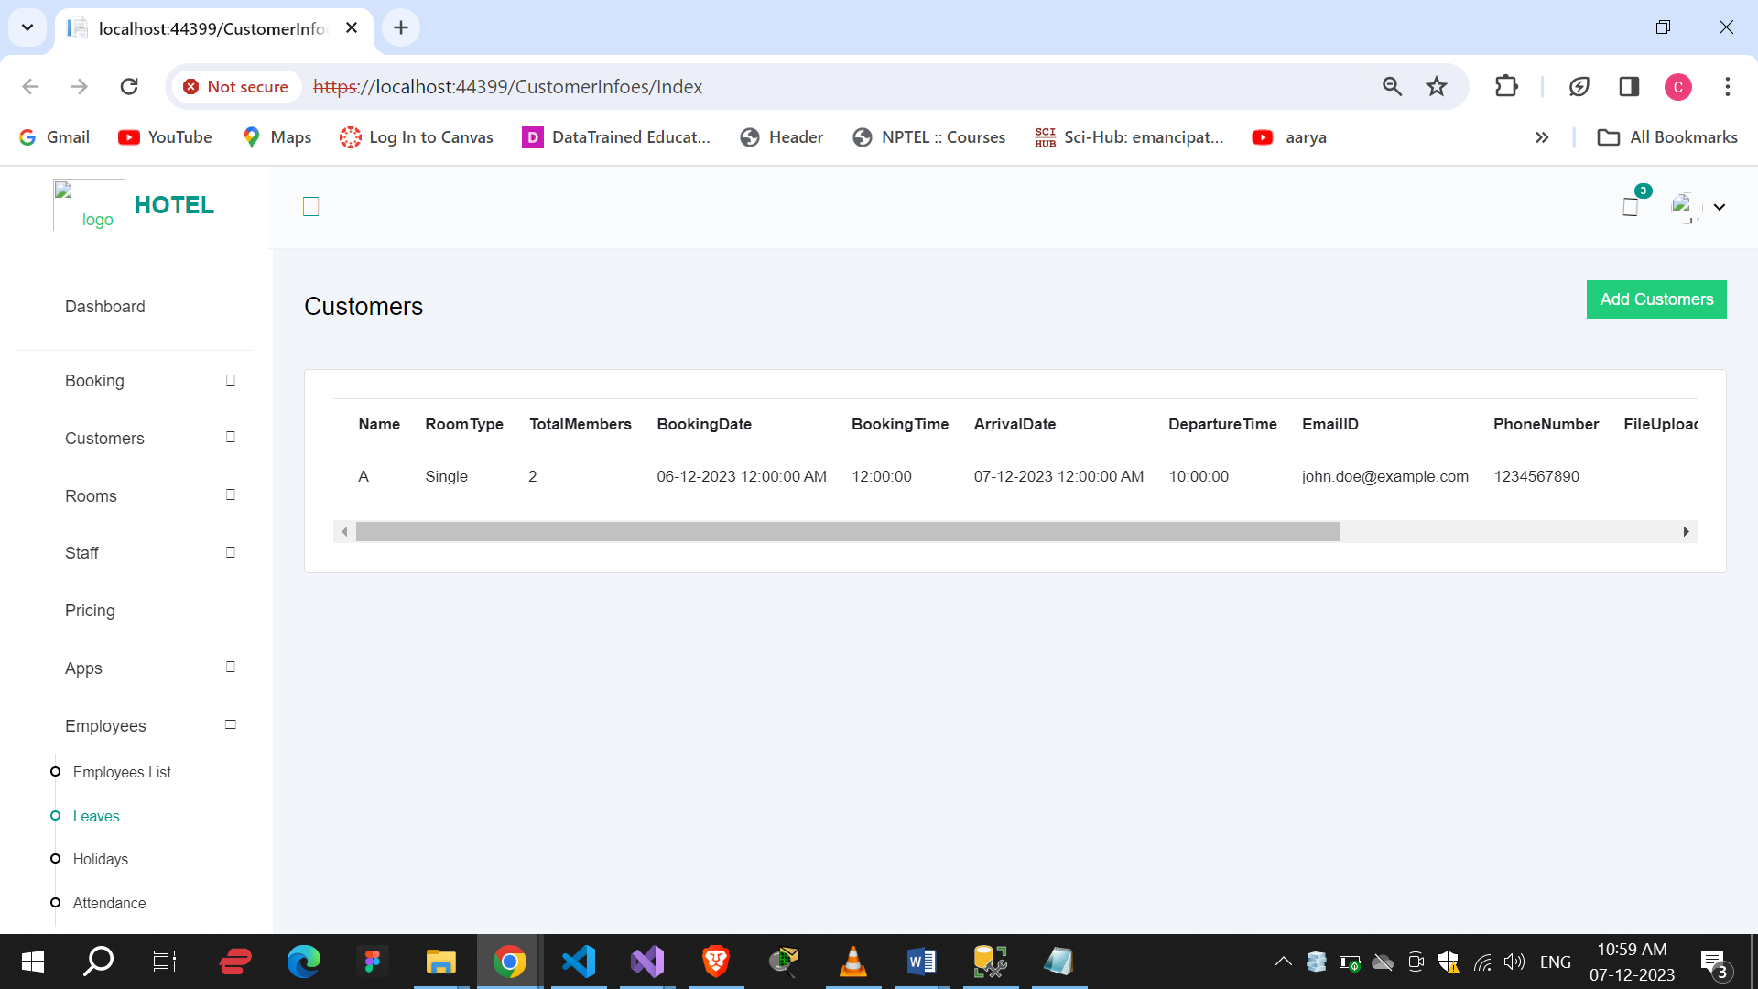

Add Customer :

By the we can add new customers.

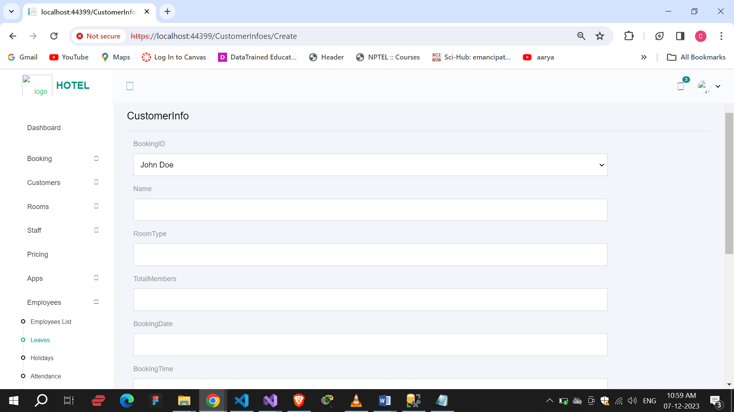

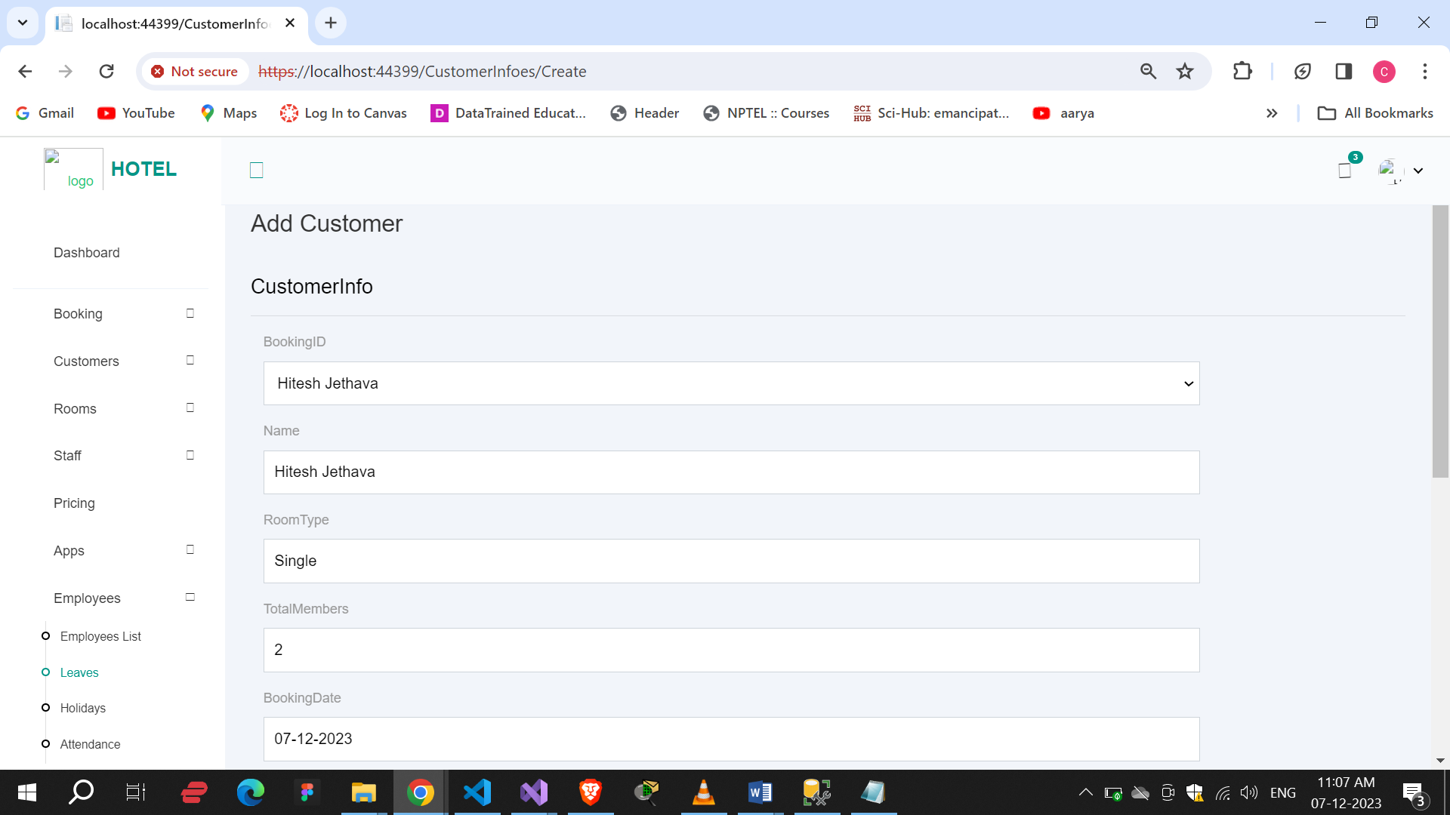

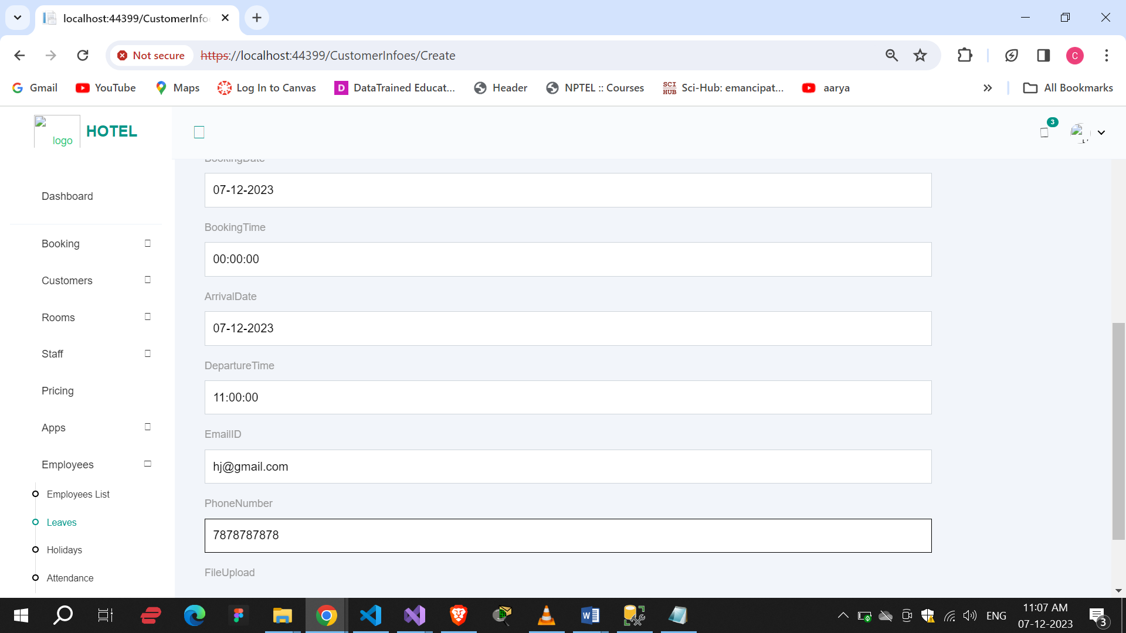

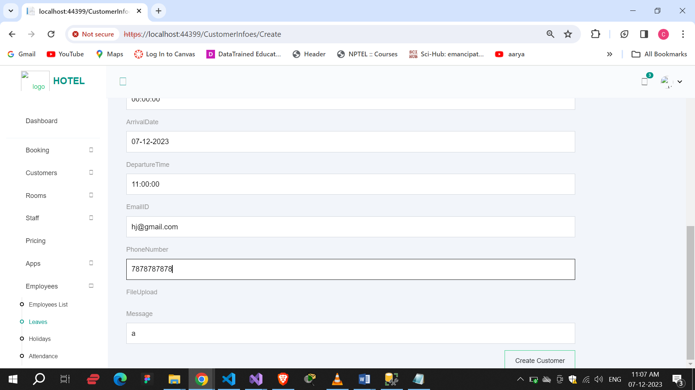

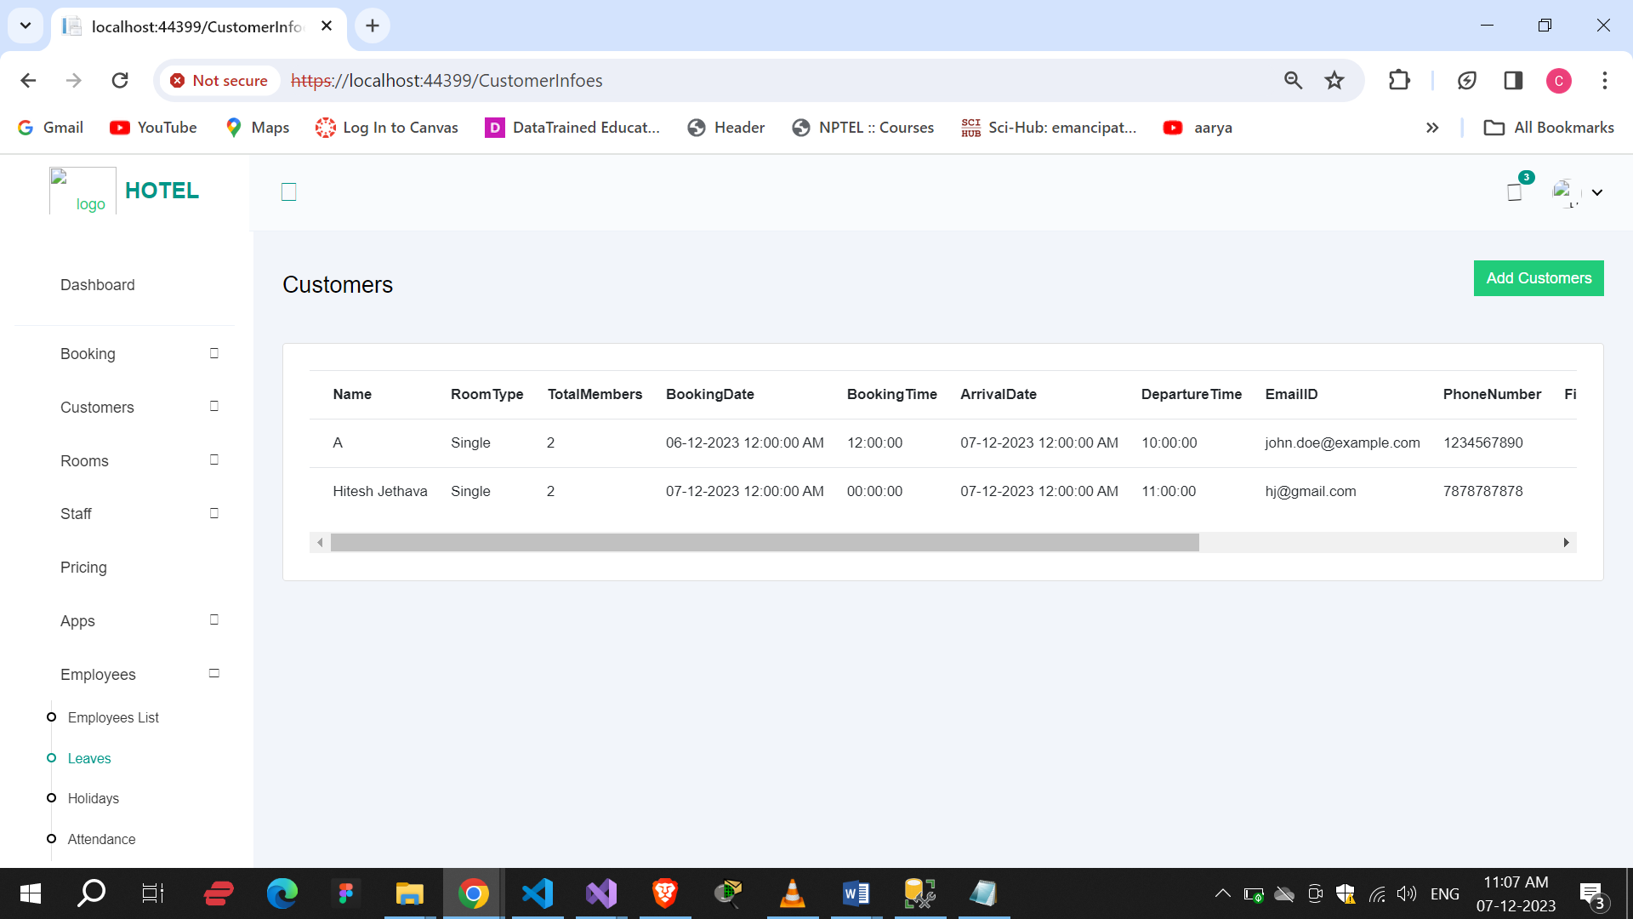

Details :

By clicking on details we can see perticular customer’s information.

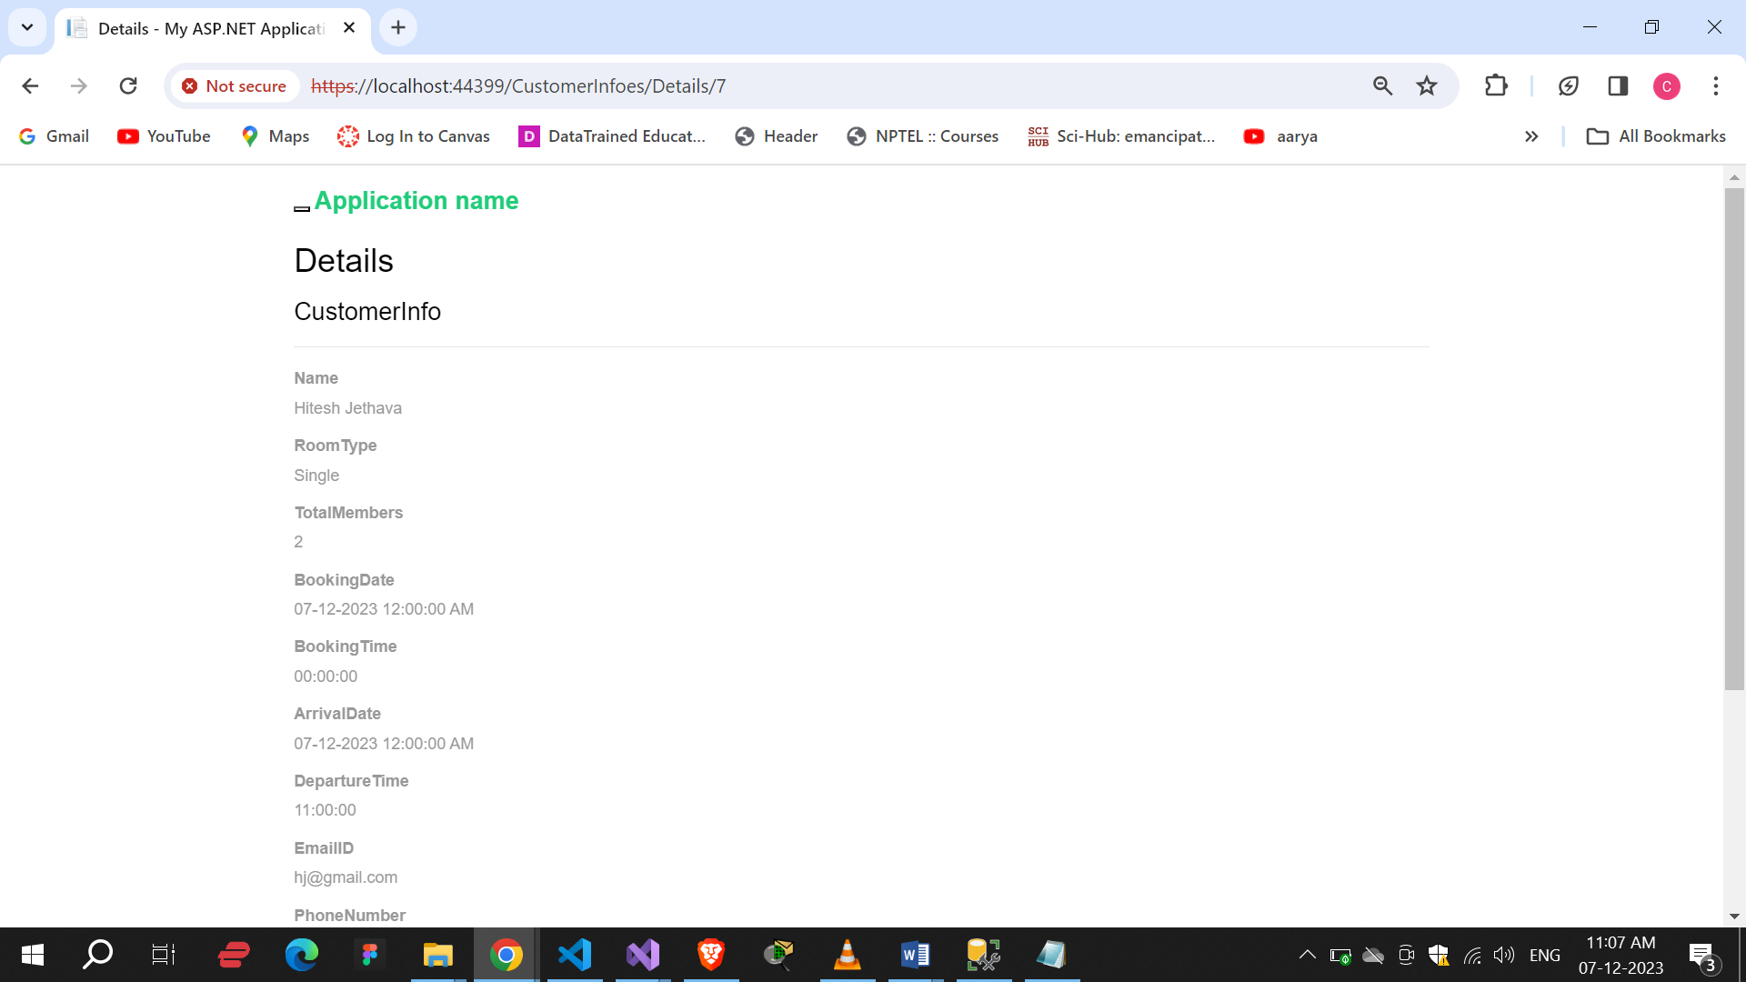

Edit :

Here we can edit the customer’s details.

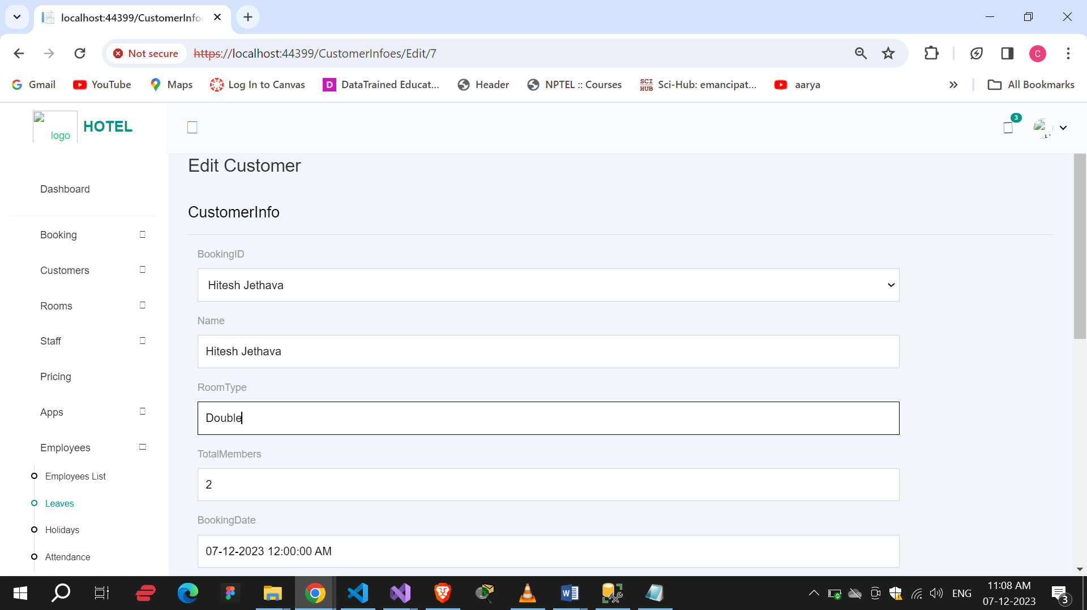

Here we can see all the customers.

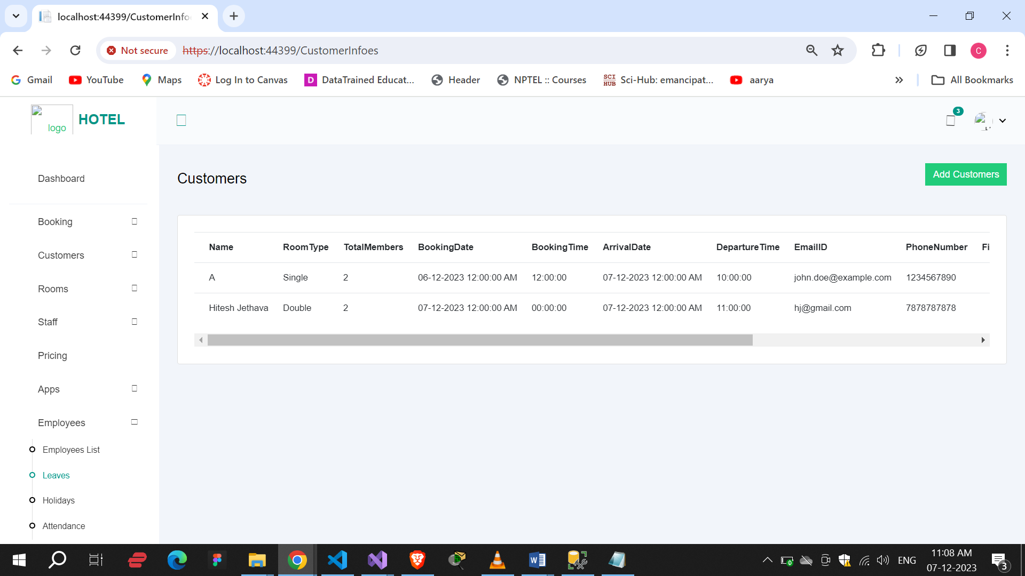

Rooms :

This is the room page. By clicking on Add room button we redirect on add new room page.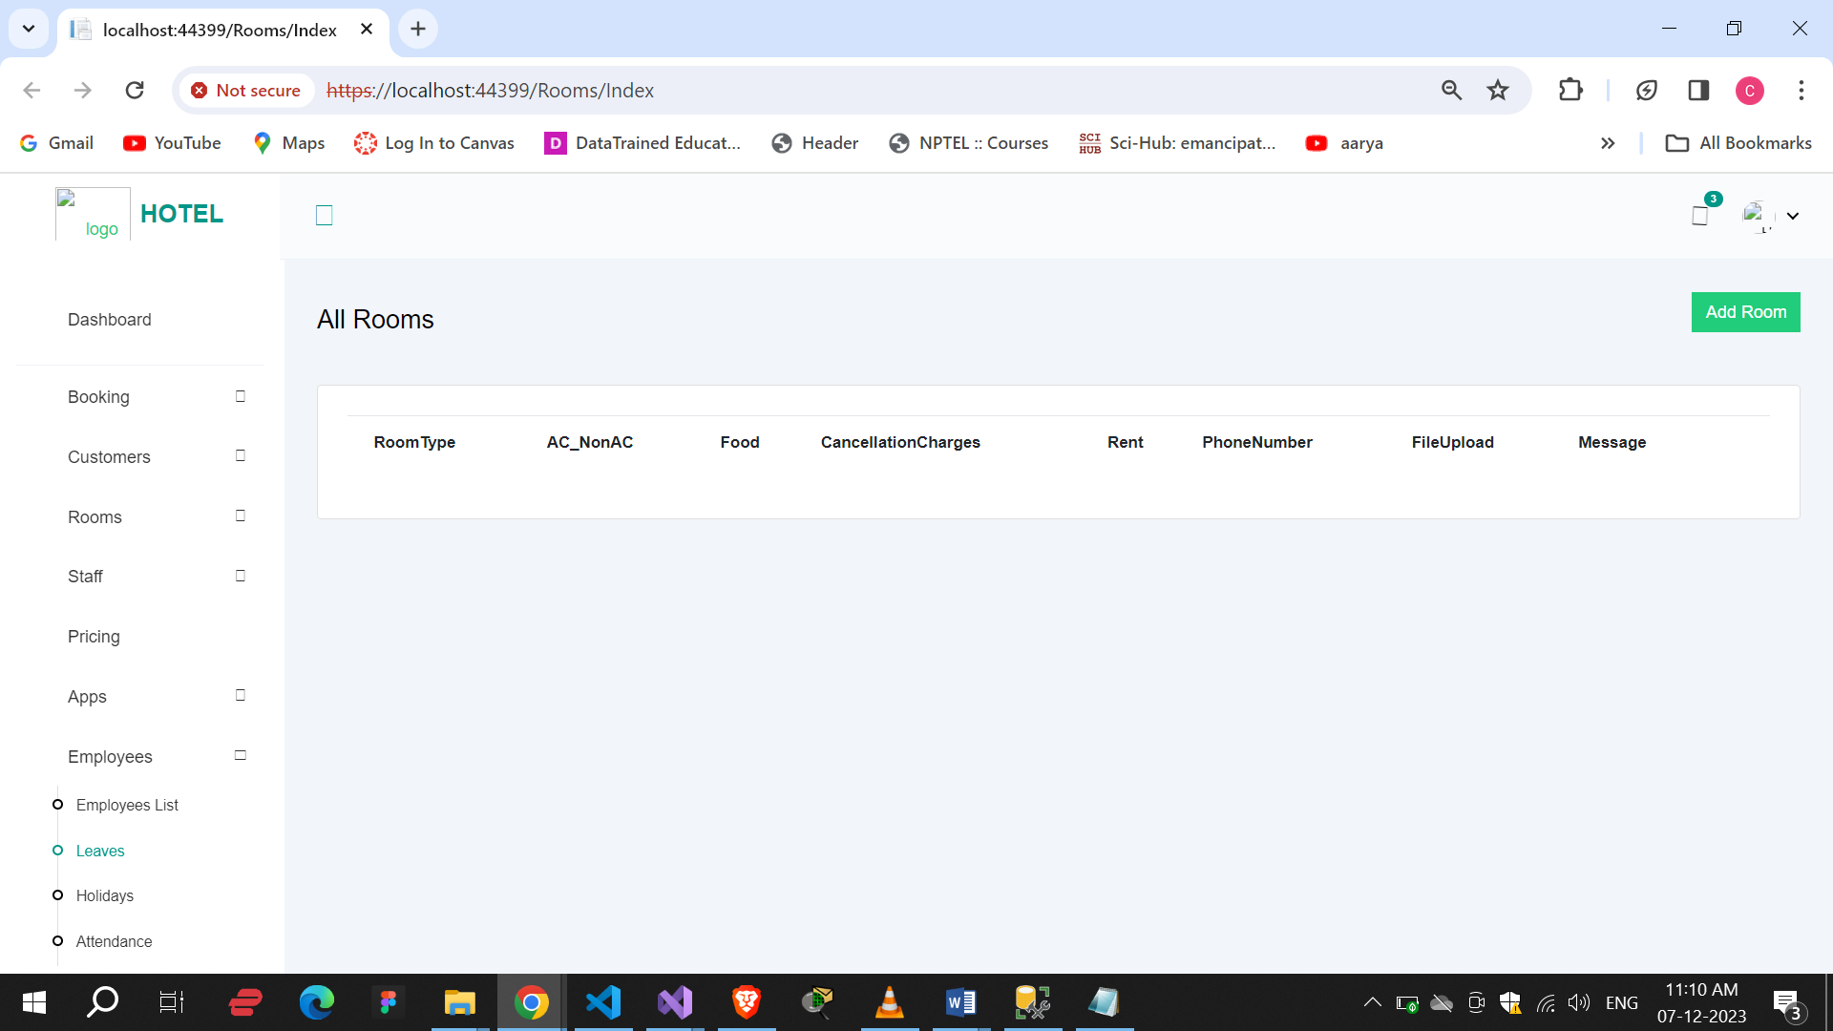

Add Room :

By this we can add new room.

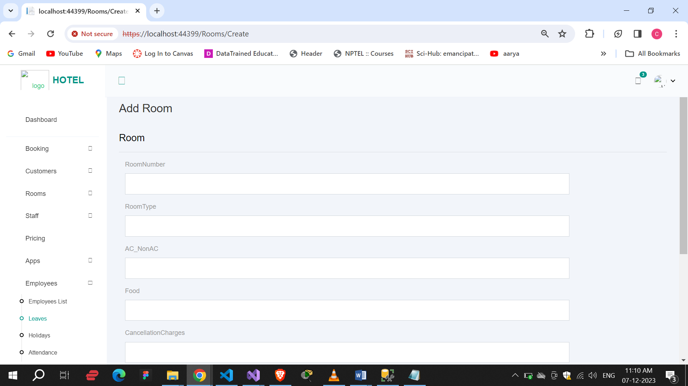

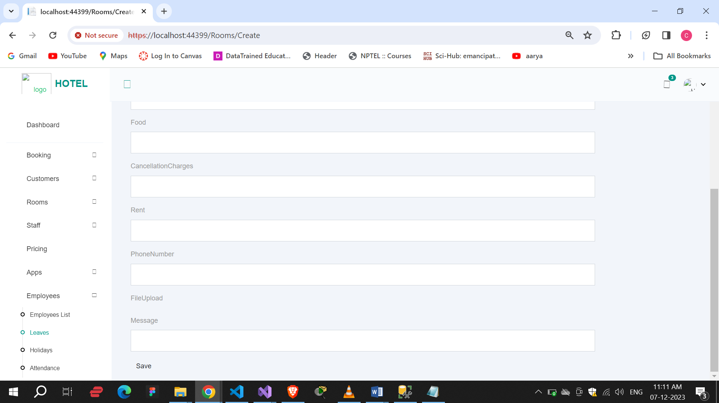

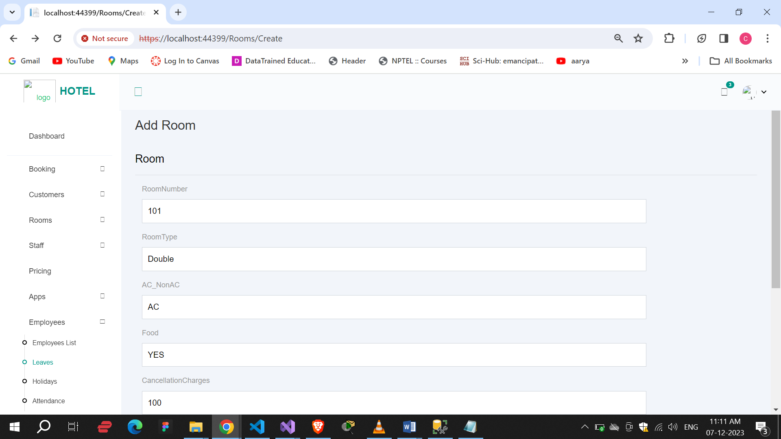

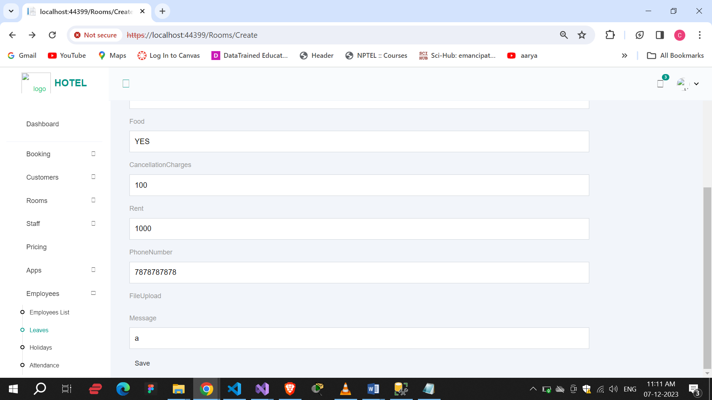

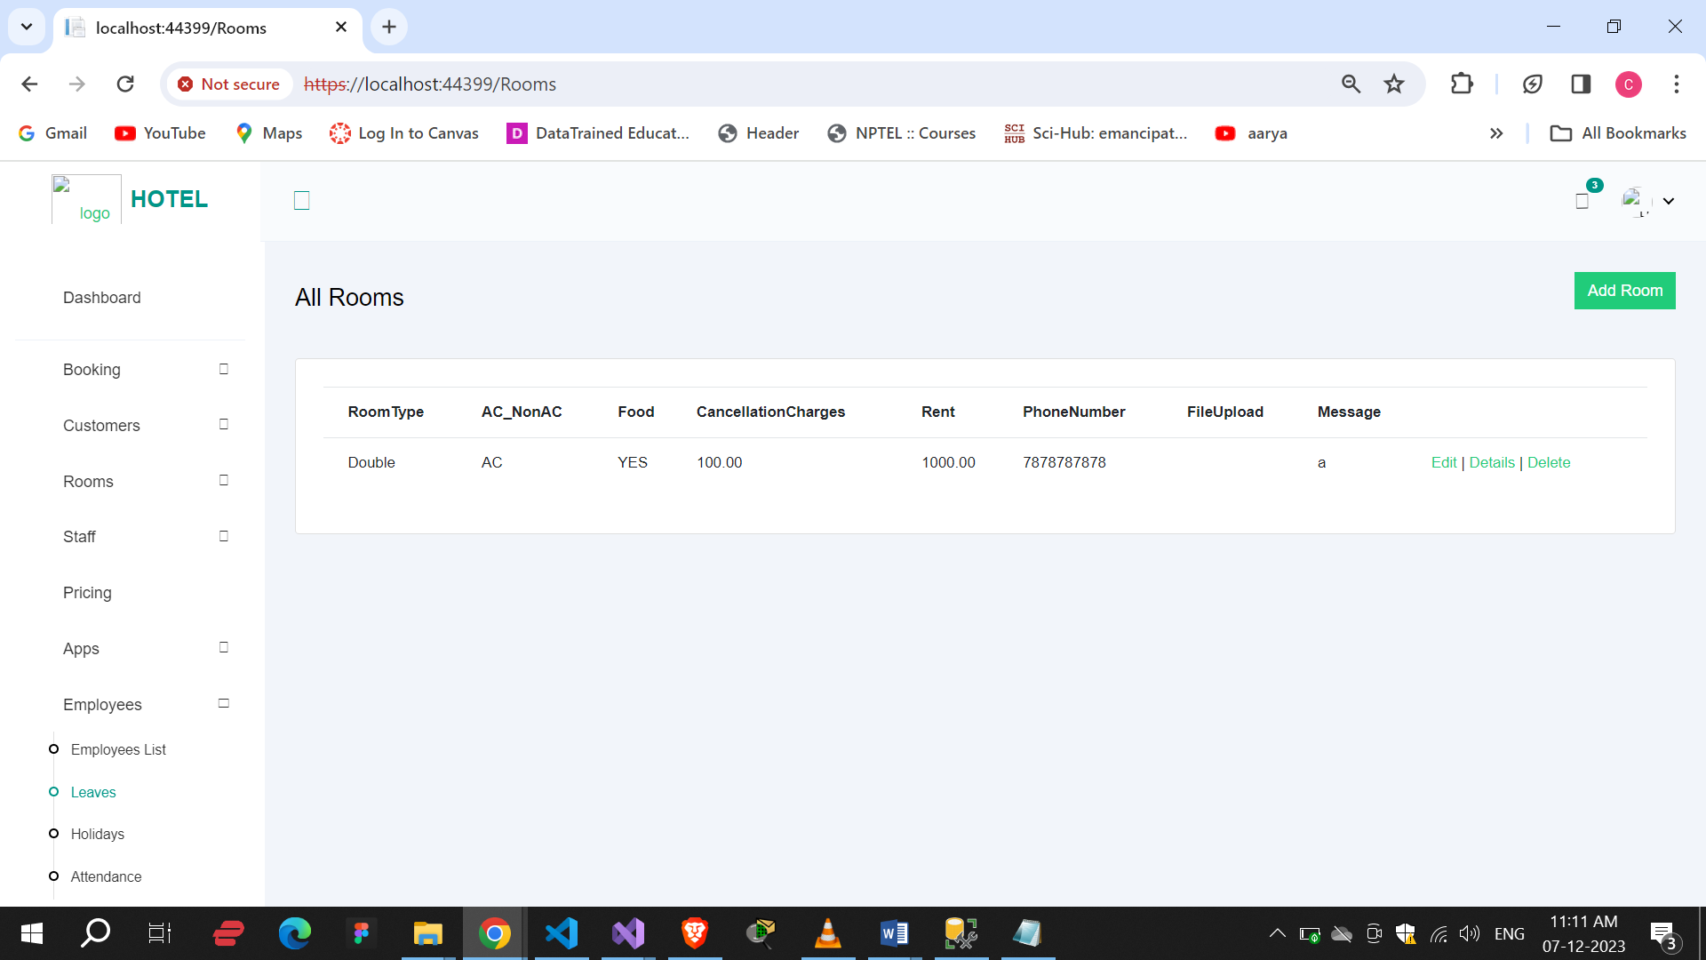

Edit :

By edit we can edit the room’s details.

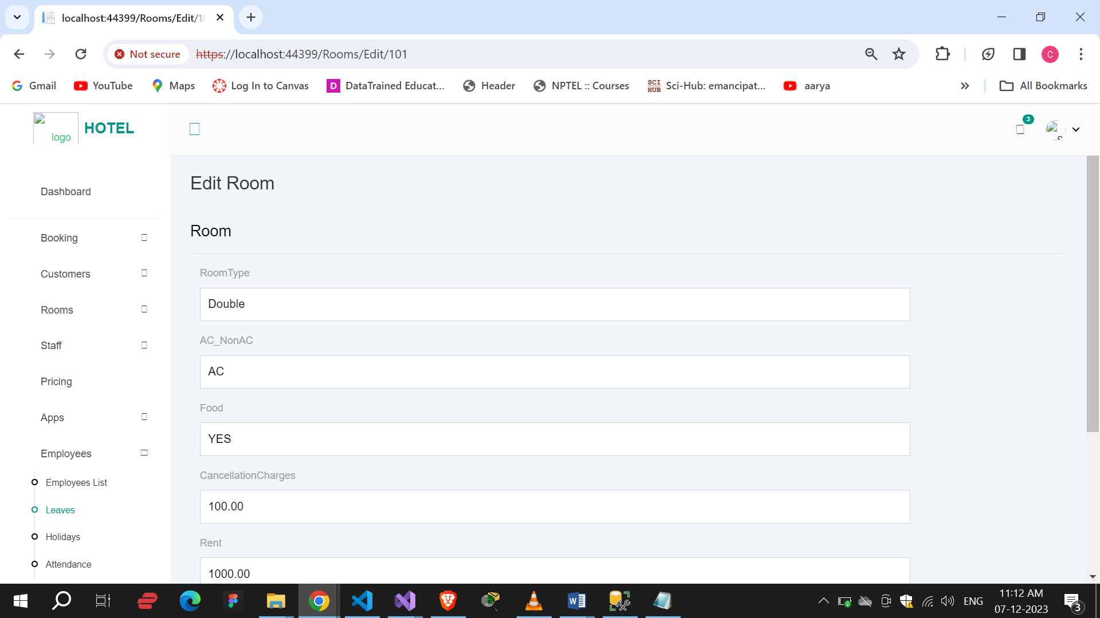

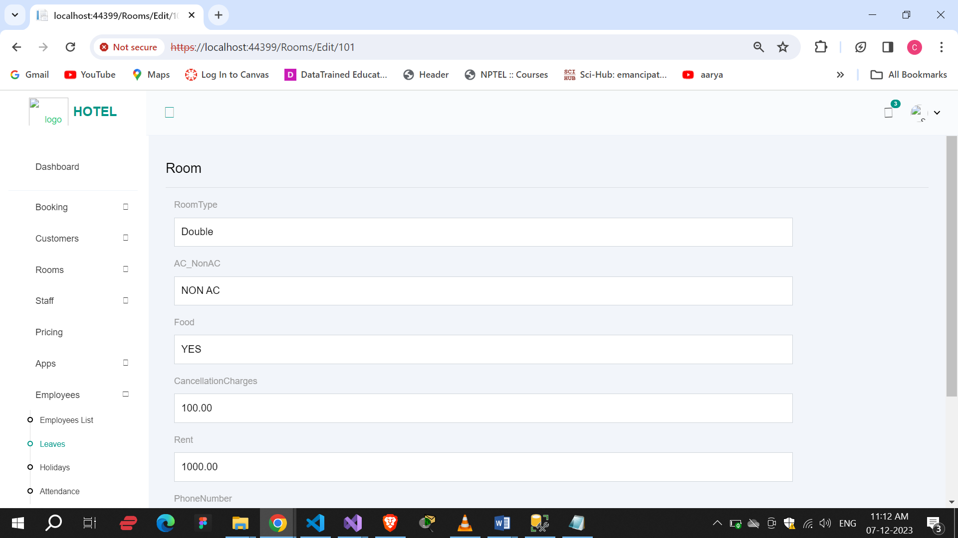

Here we can see all room’s details.

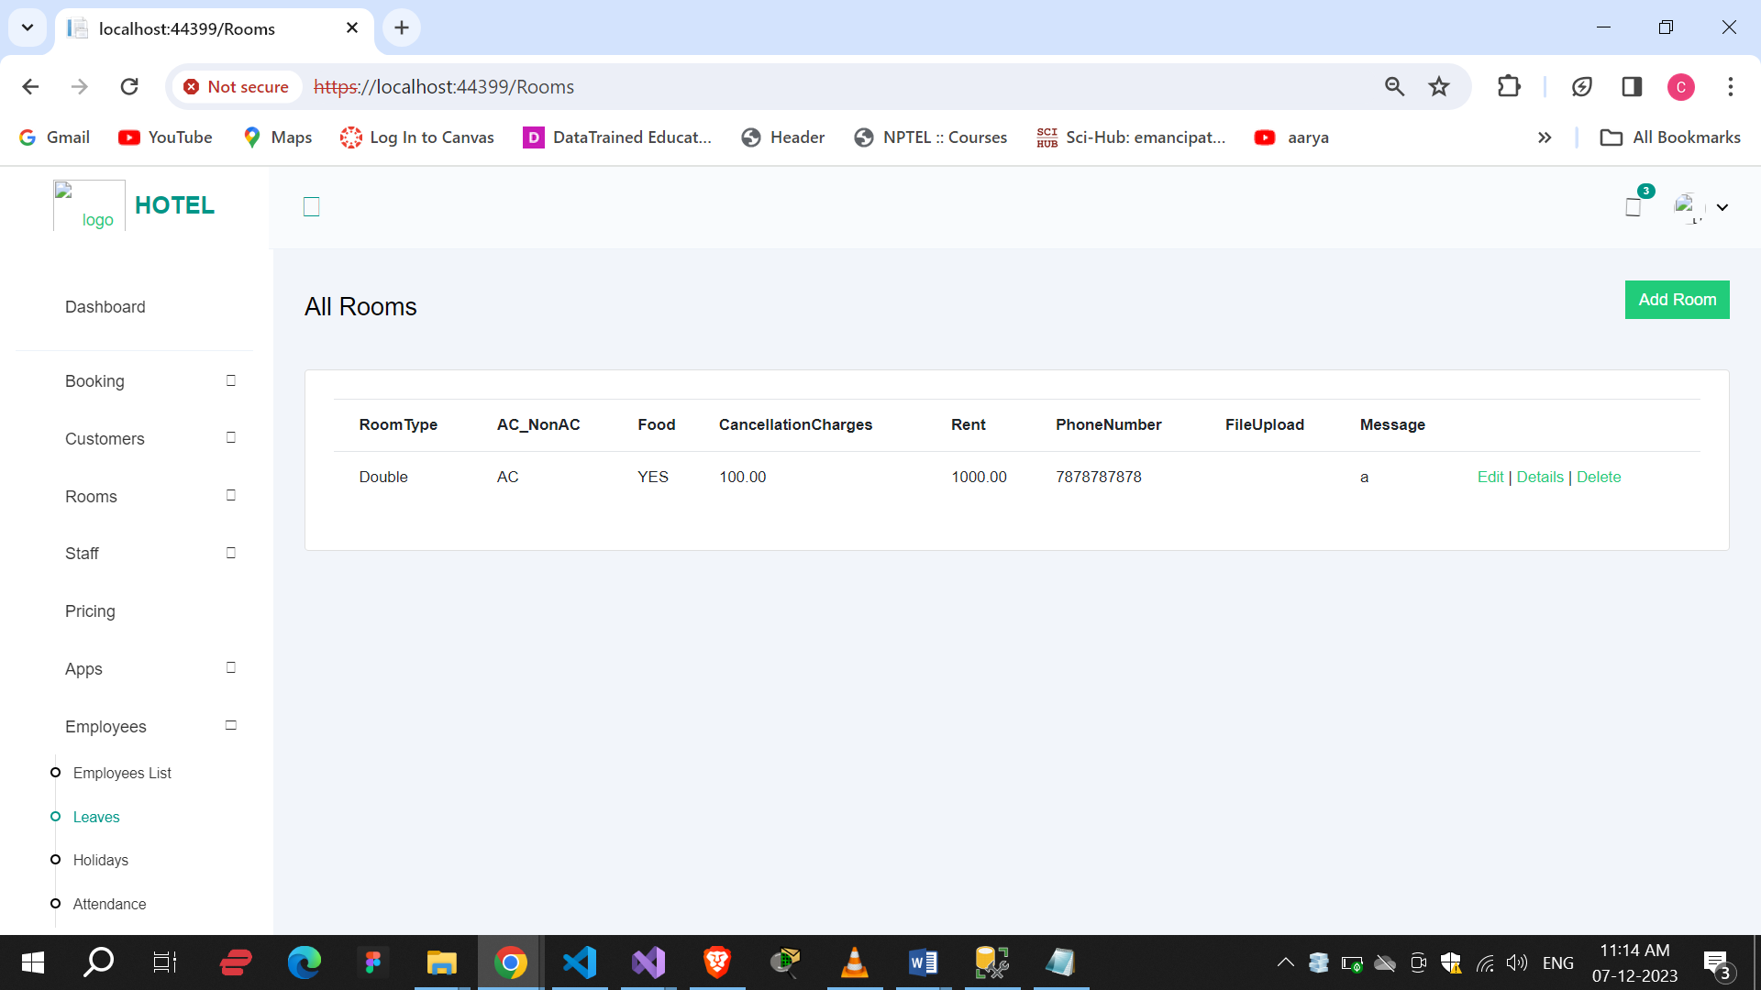

Delete :

By delete, we can delete rooms details.

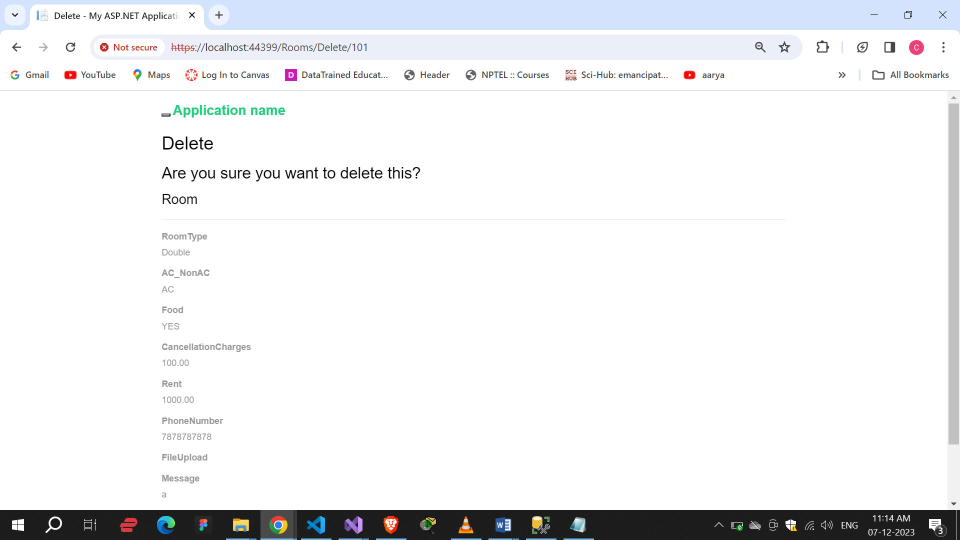

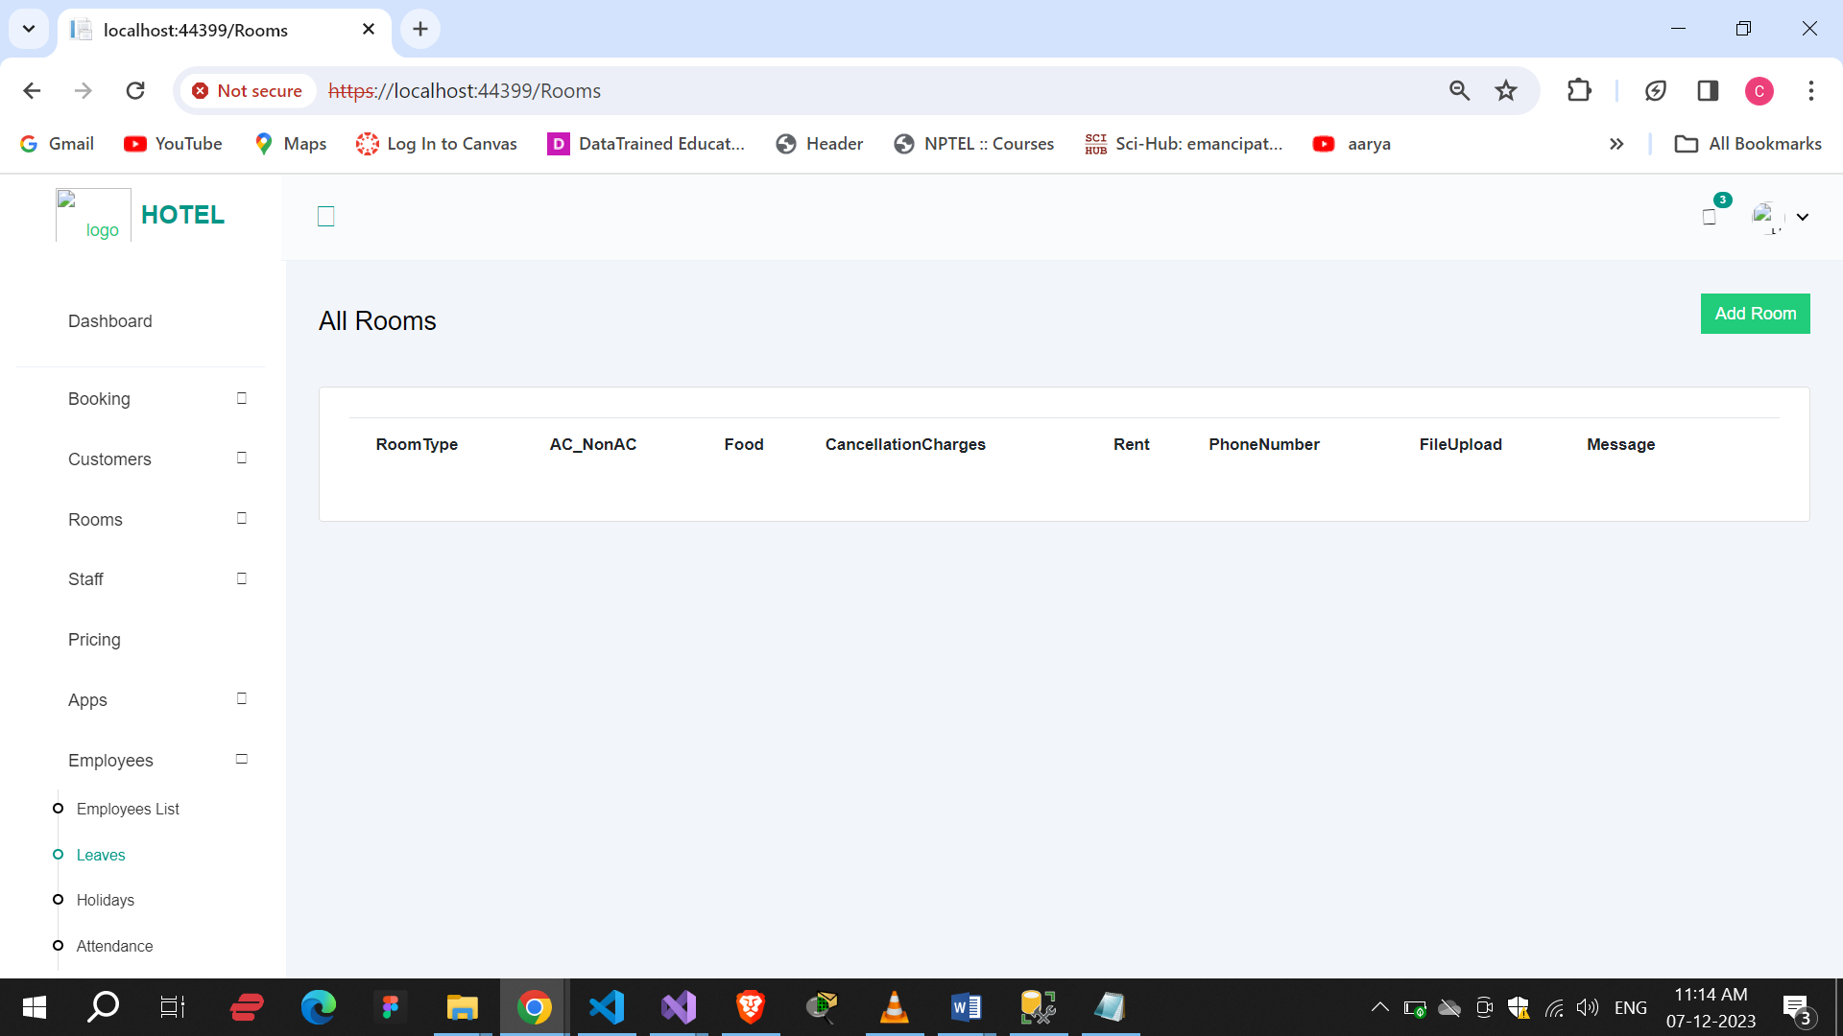

Staff :

In staff, all the details of staff with positions. By clicking on add staff we redirect to add staff page.

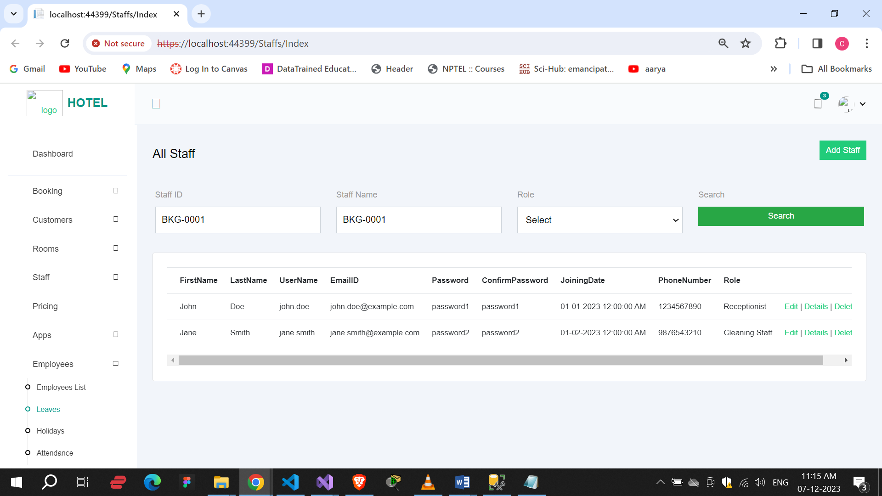

Add Staff :

By this , we can add new staff details.

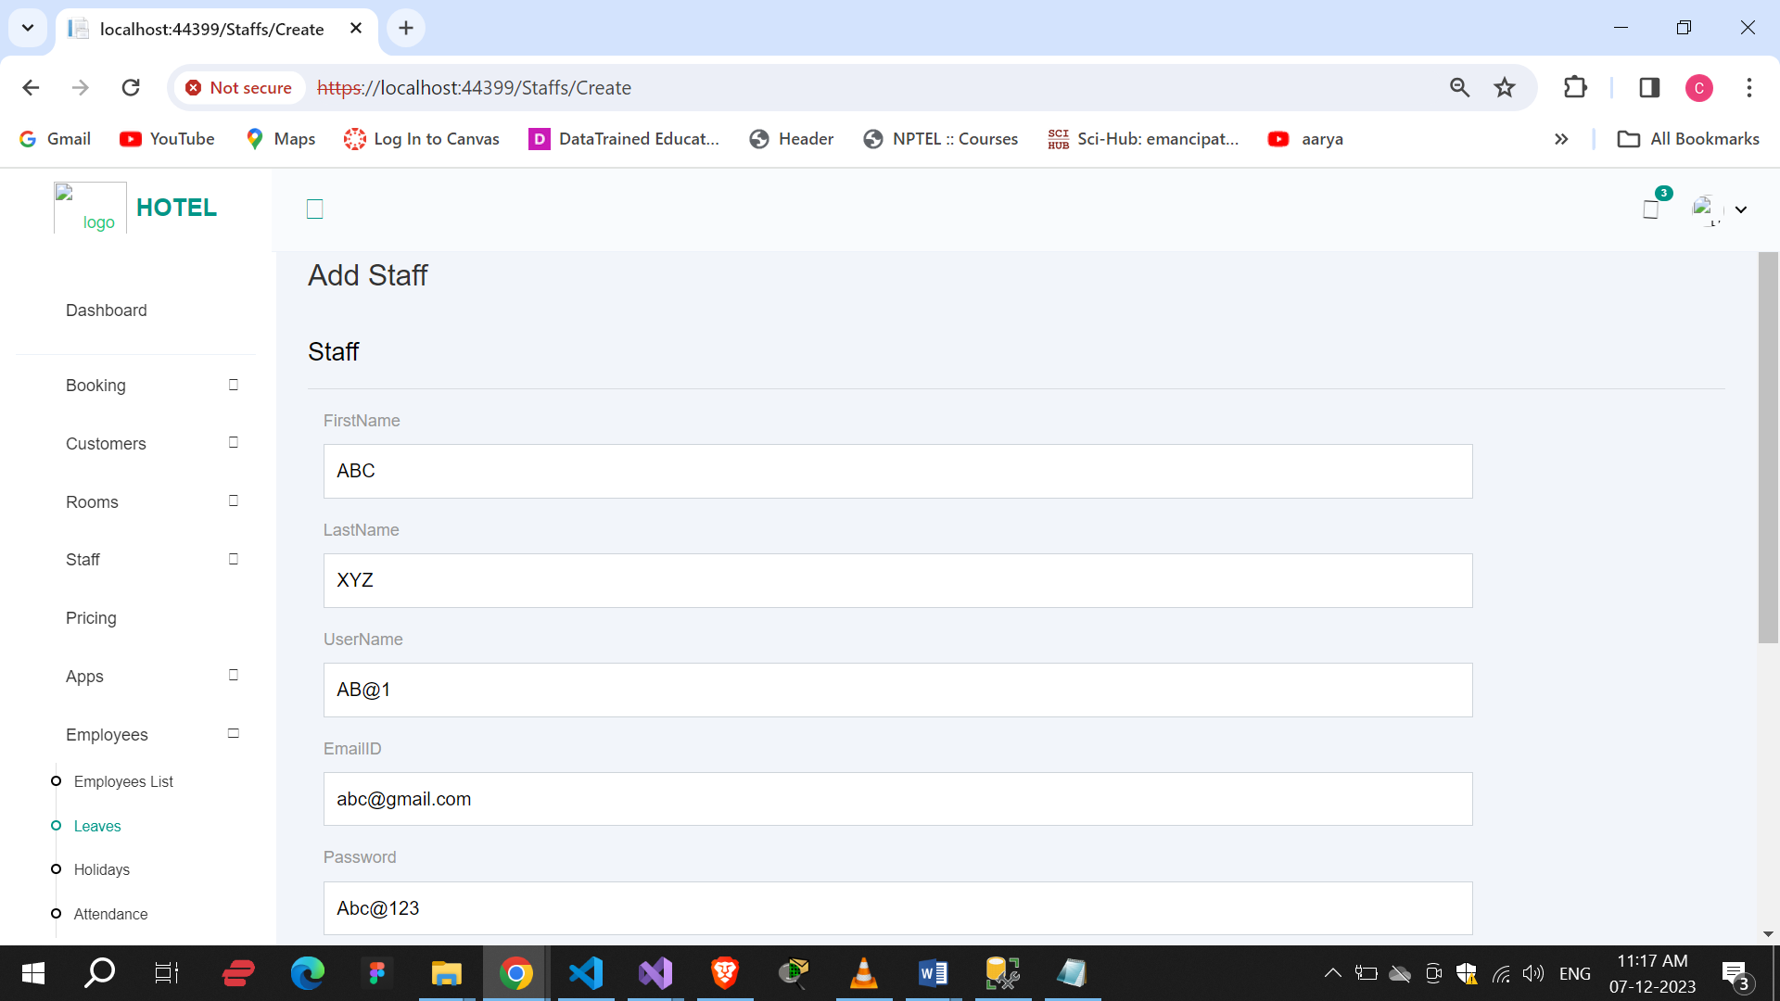

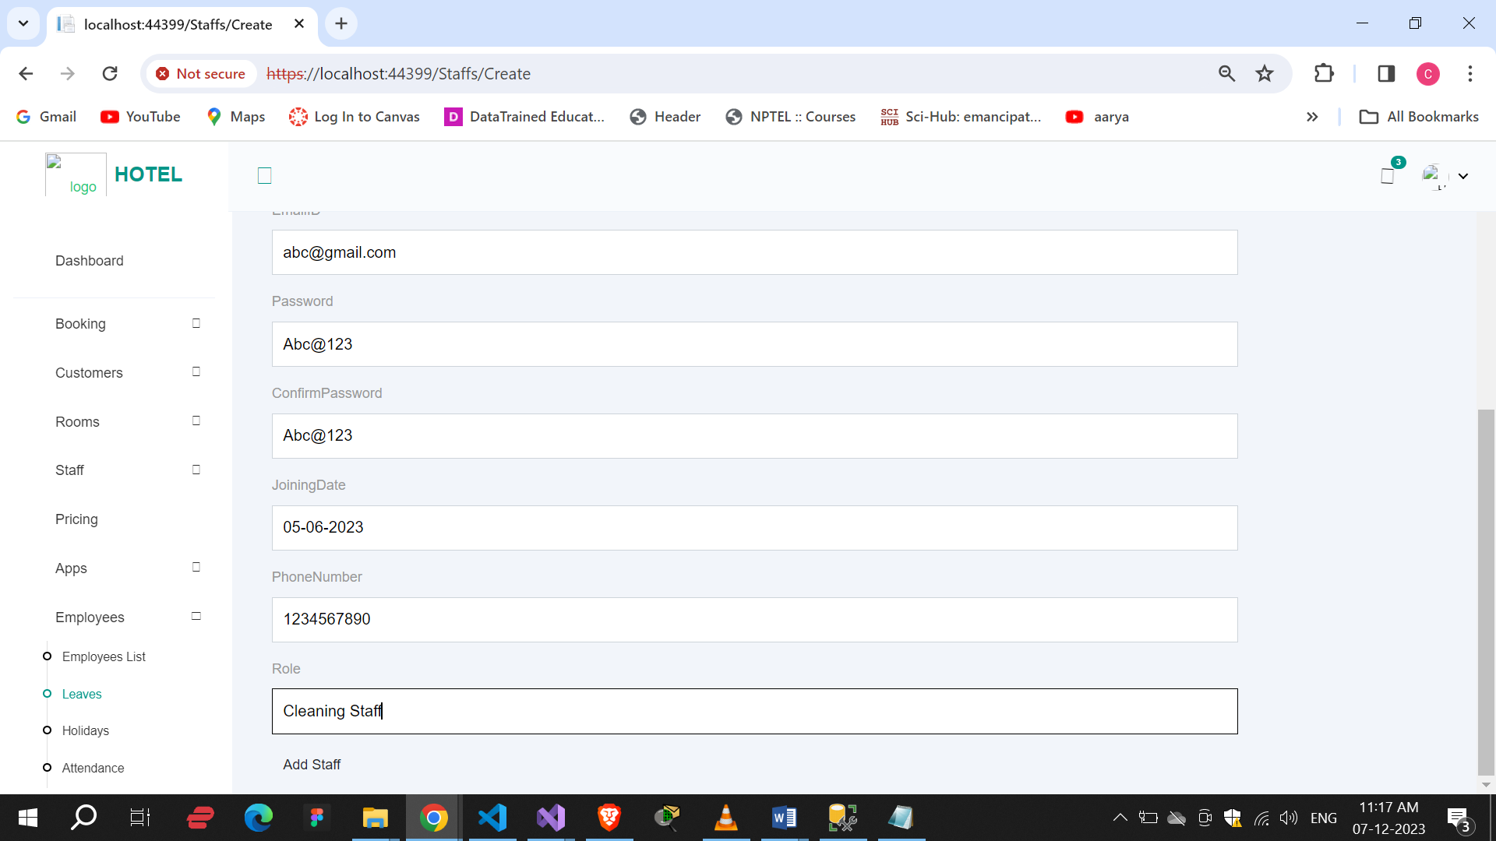

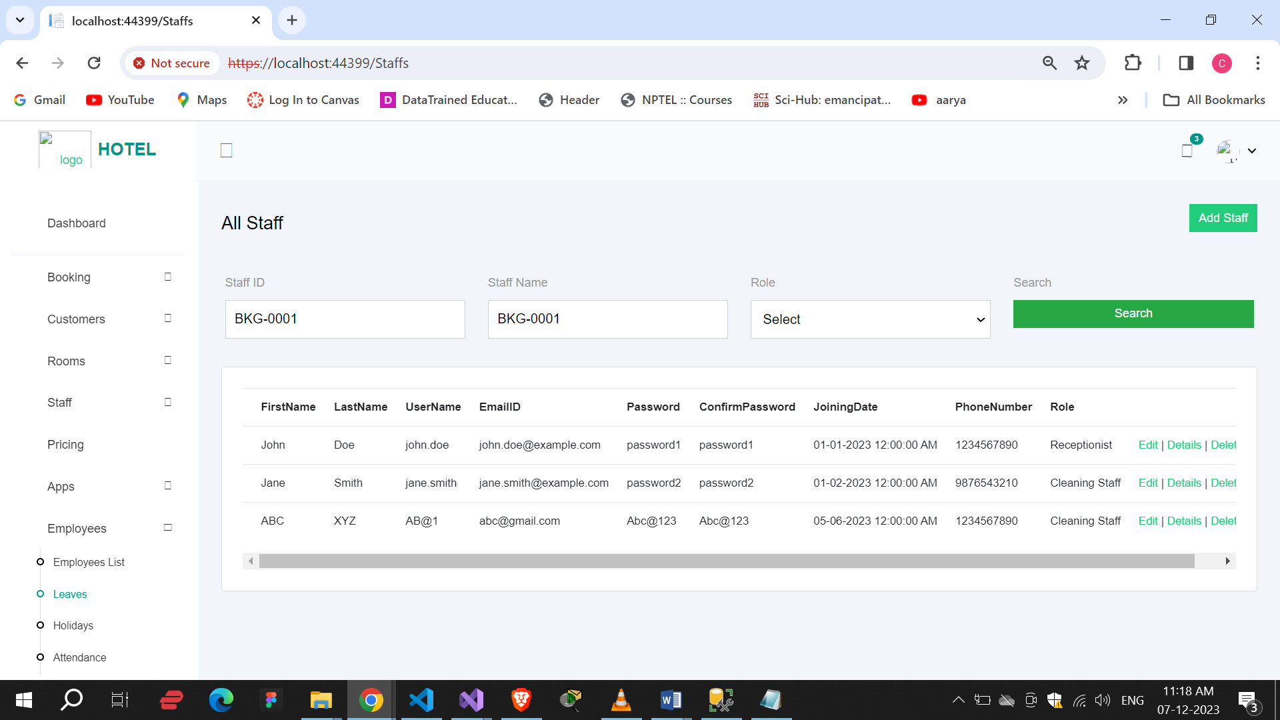

Details :

Here we can see by click on details button perticular staff member details.

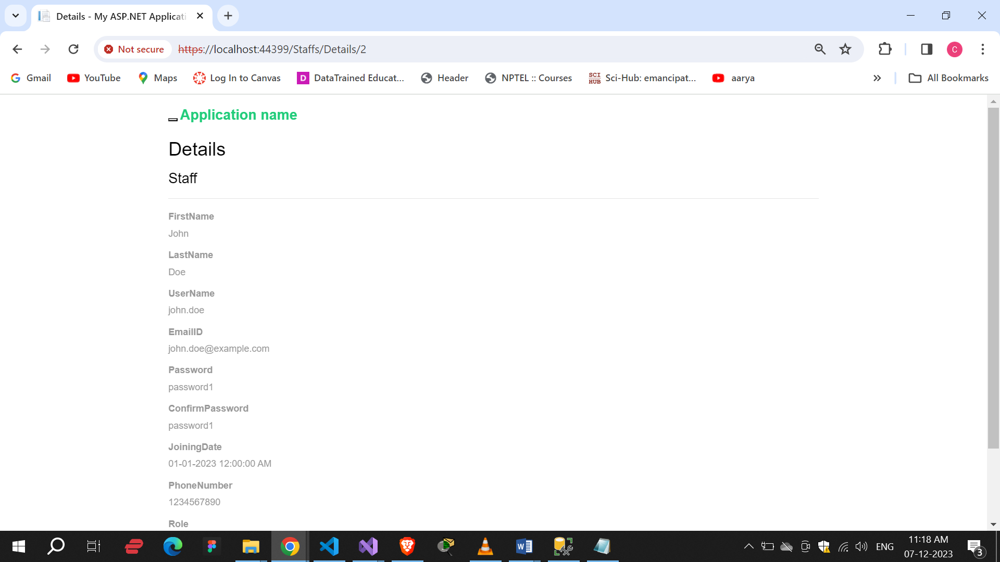

Edit :

By this , we can edit the all details of staff.

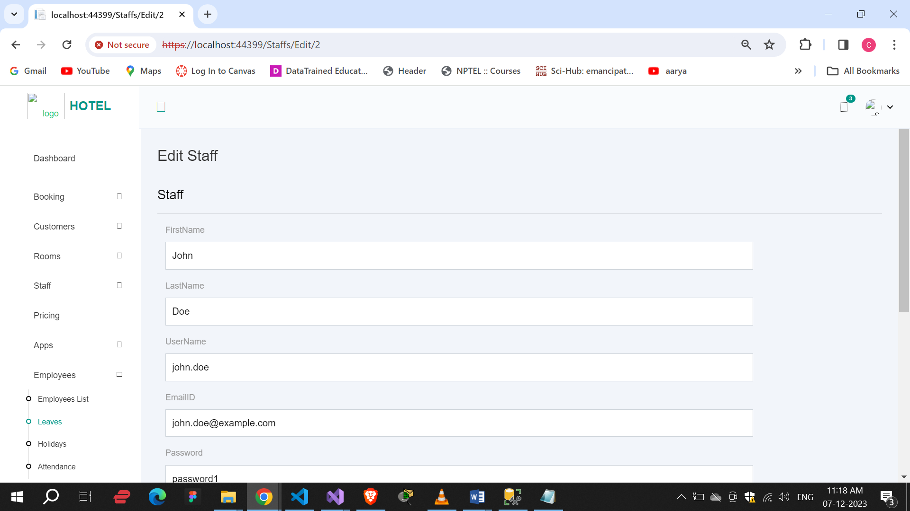

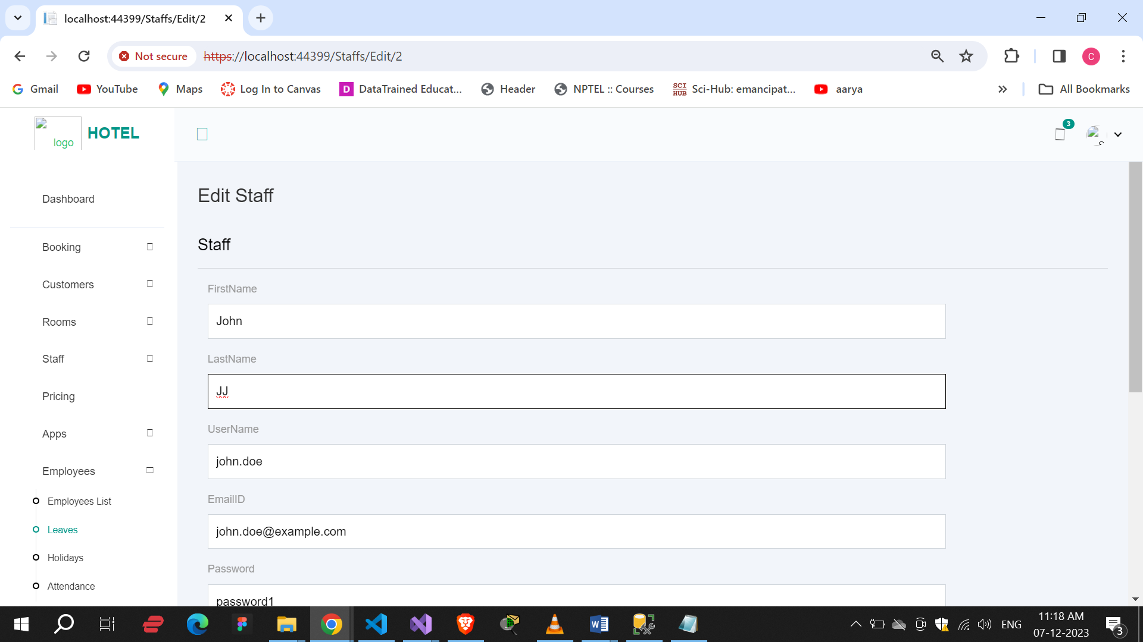

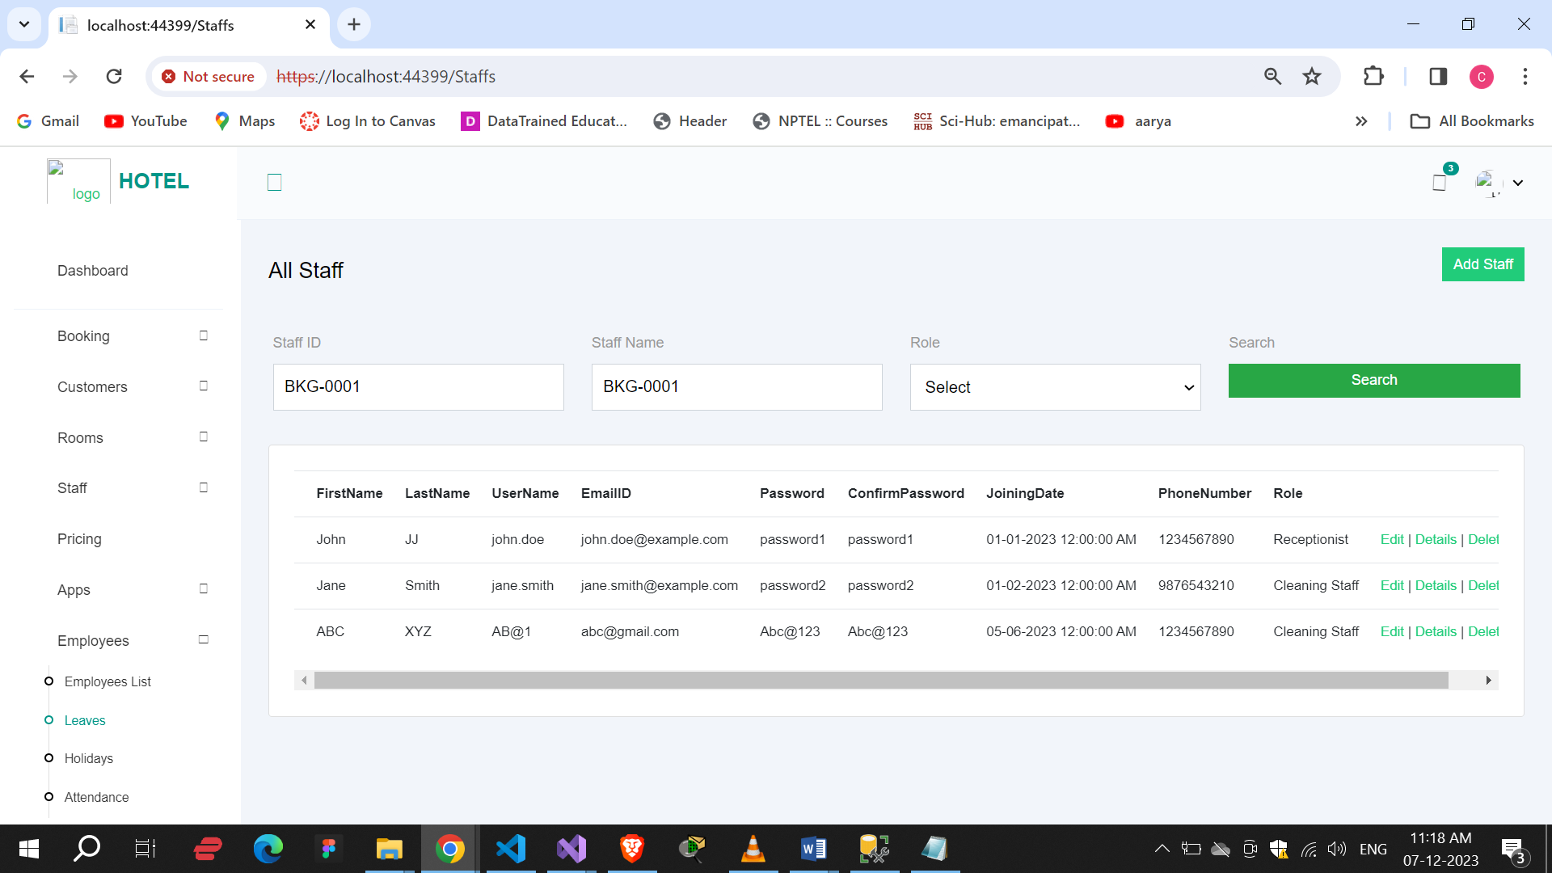

Delete :

By clicking on deldete button we can delete staff member details.

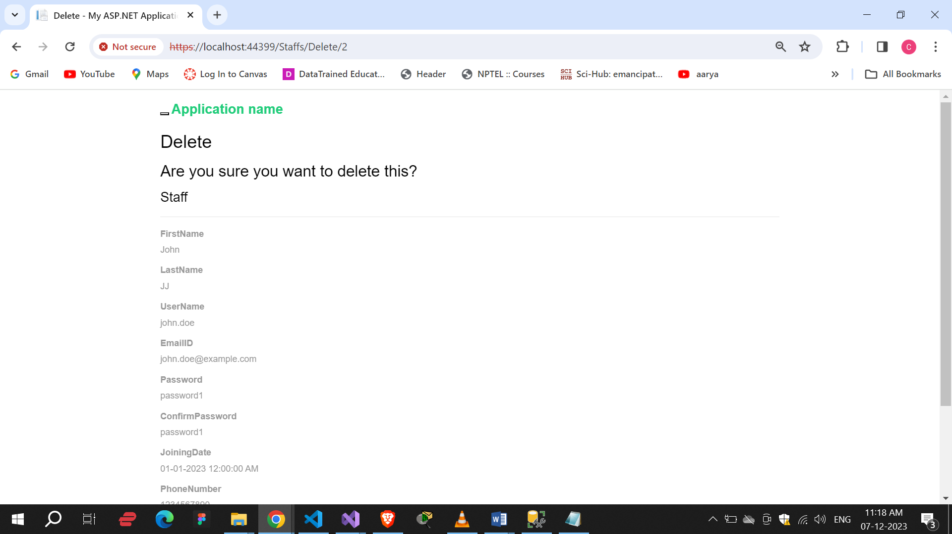

Here we can see all staff detals.

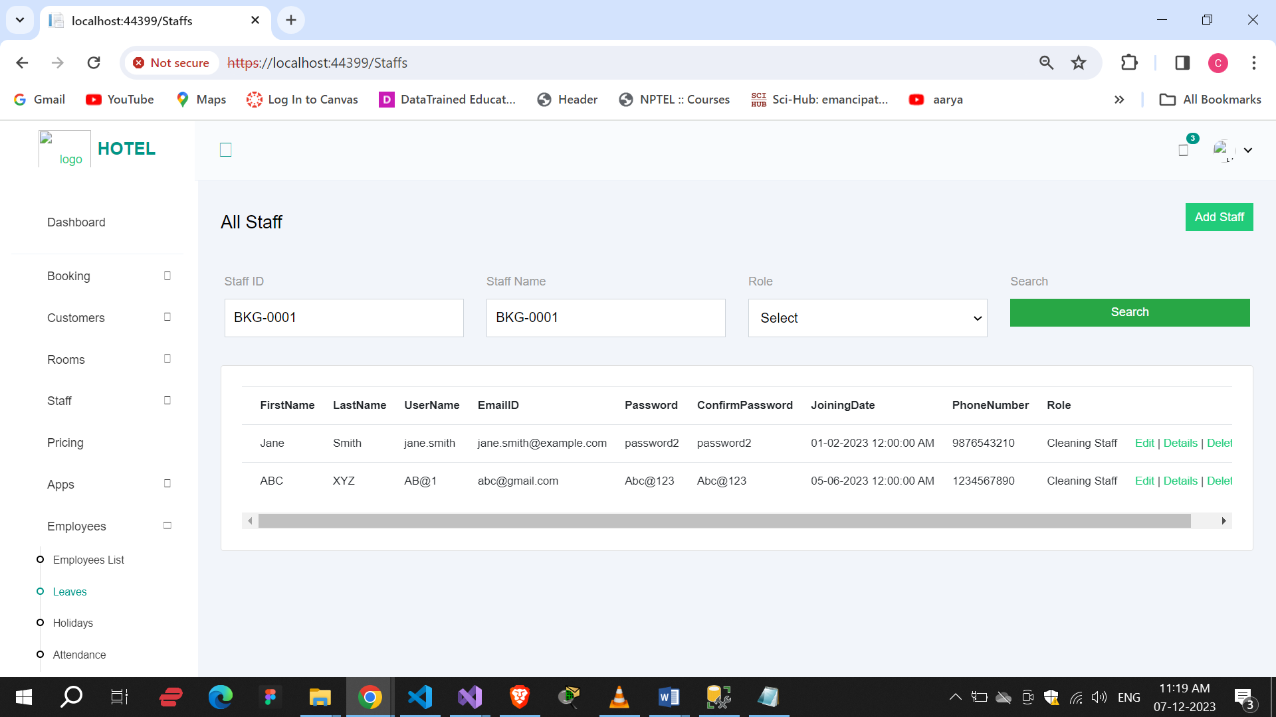

Data:

In this, all details about query, data table.

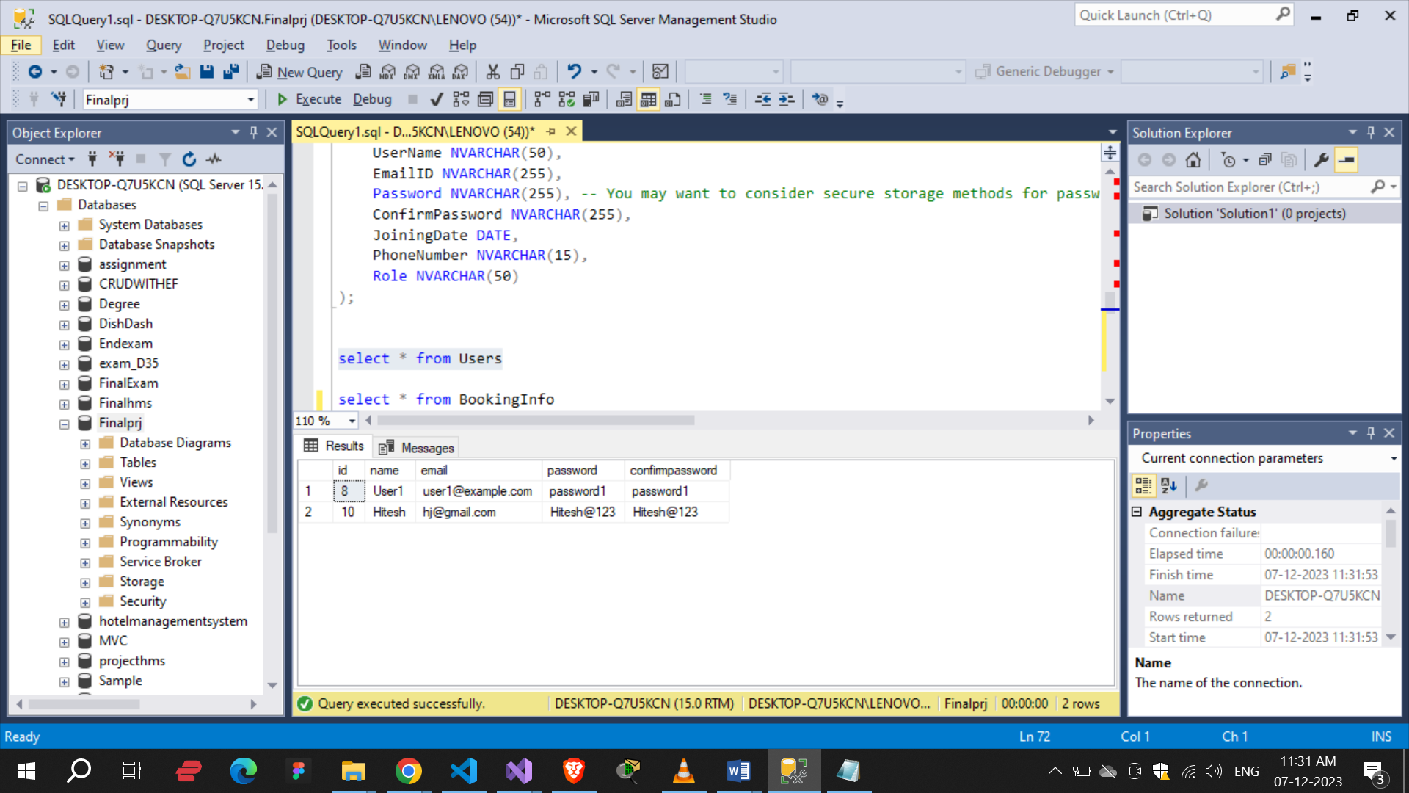

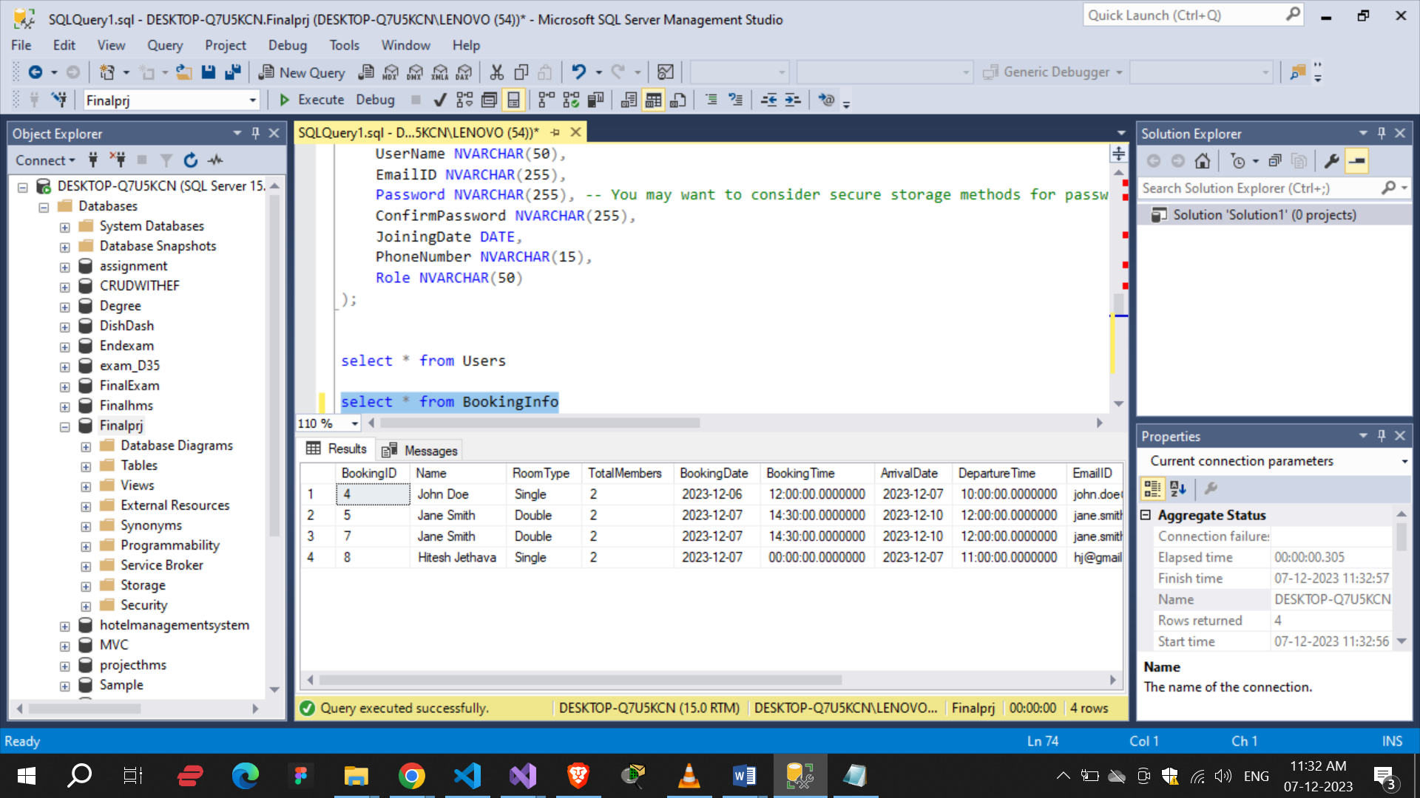

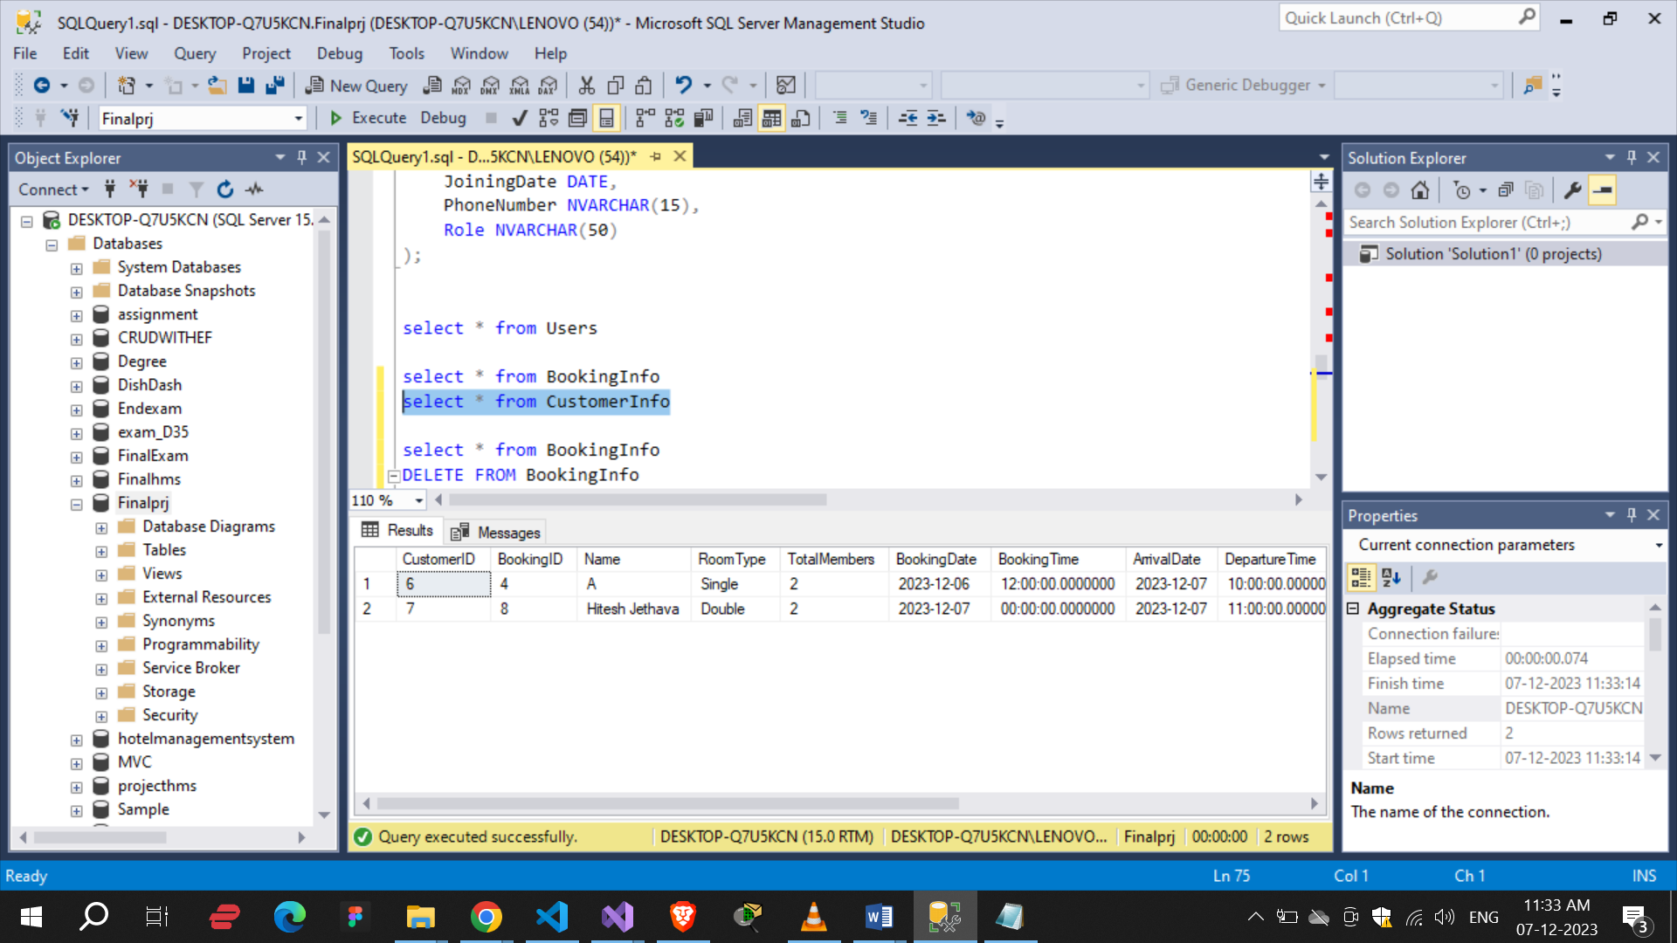

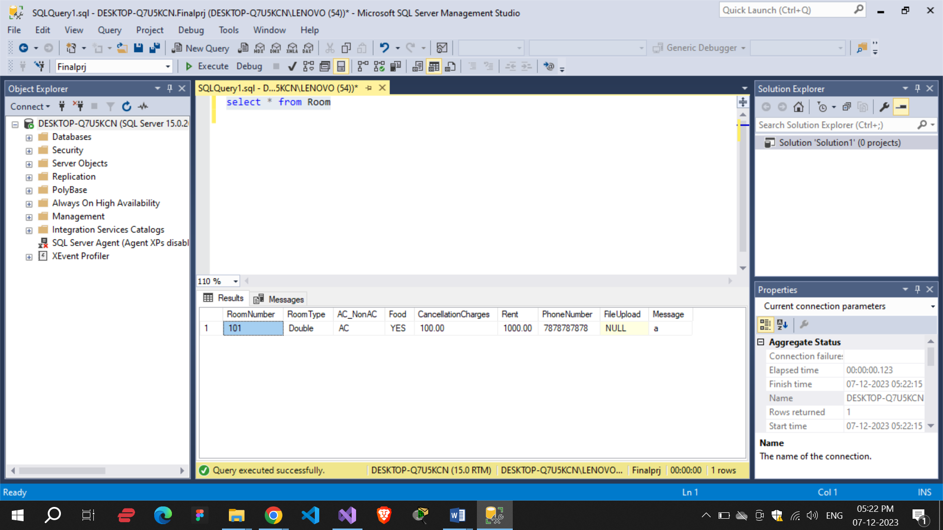

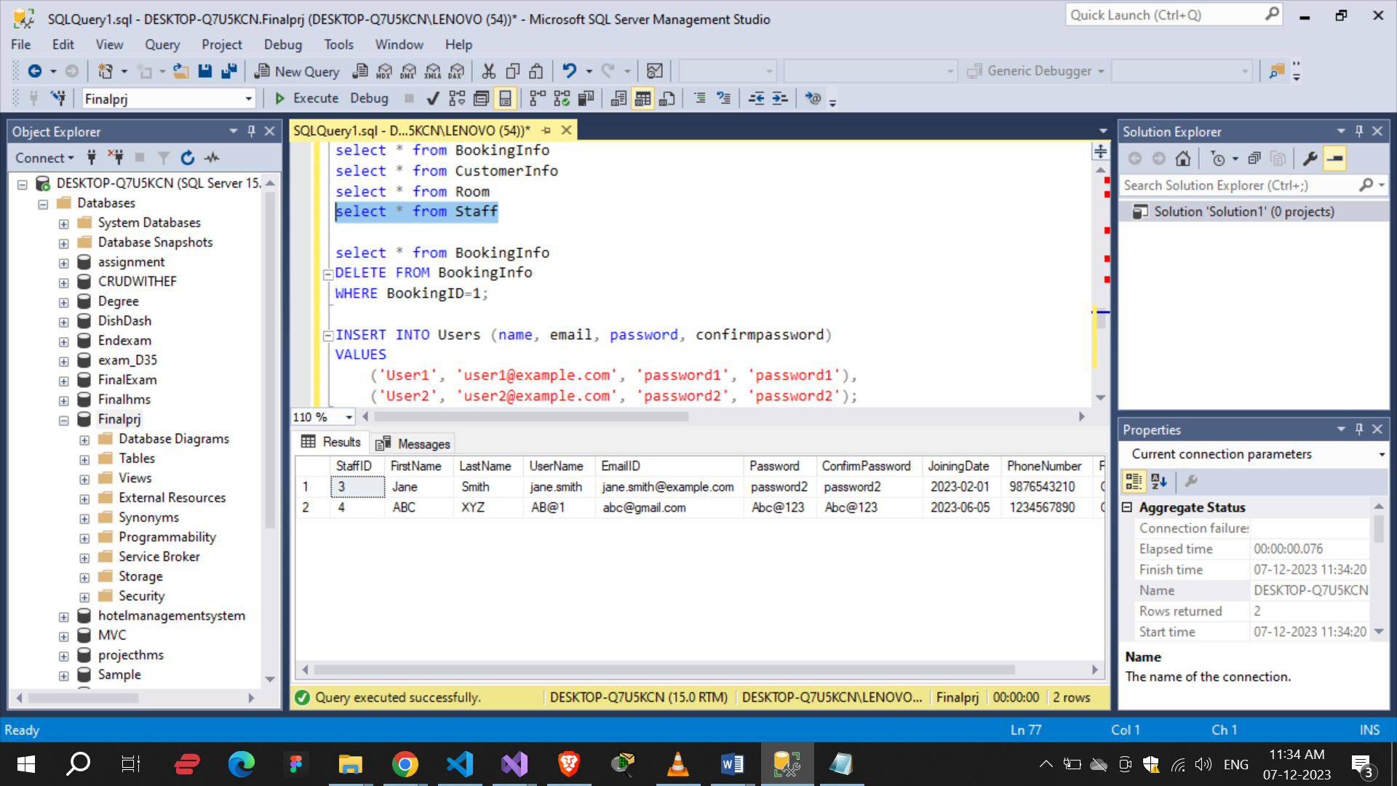

Data Flow Diagram :

Users

Hotel

(Database)

()

Level 1 : Booking Process:

Manage Room Info

Rooms

Booking Info

Manage Customer Info

Make Booking

Check Availability

Users

Conclusion :

In conclusion, I have learnt from this project about C# .NET, MVC, NET Framework and also database. How to work web site and how to manage all the thing in web application. How to approach of errors and how to solve the errors, troubleshooting and all. So I got knowledge about Frontend technology also.